Language: two meaning in english
- language spoken by a community (italian, french…)
- common properties of all languages in the world

Semanticity: you use language to convey meaning
Displacement: with language you can speak about the future, the past and thing that are near and/or far away. Animals can not speak about the future or the past
Metalanguage: you can think about language. Linguistic is a way of think about languages

We can make action through language we can promises, order or lie

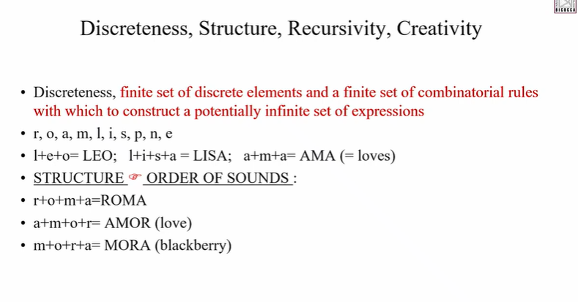
Discreteness: we have a finite set of sounds and with them we can obtain an infinite number of words and sentences

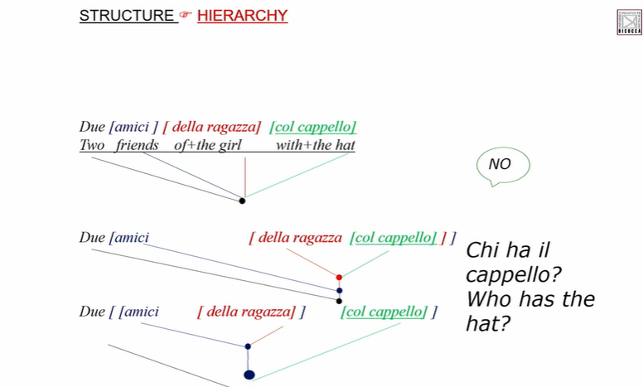
Structure: you combine words hierarchy, you attach at different level

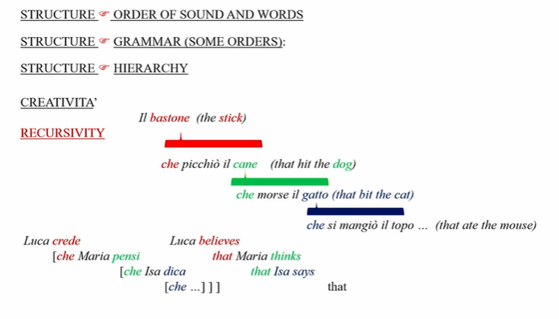

Creativity: we can invent sentences that you never heard but you can figure out something about

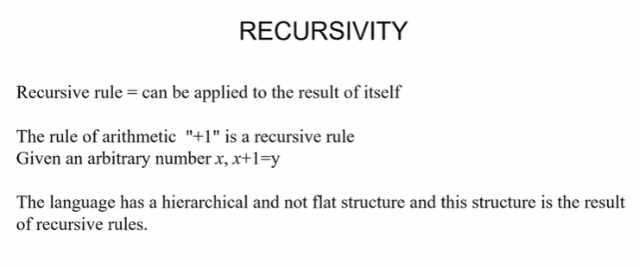
recursivity: you can apply a rule to the result of itself and obtain something meaningful

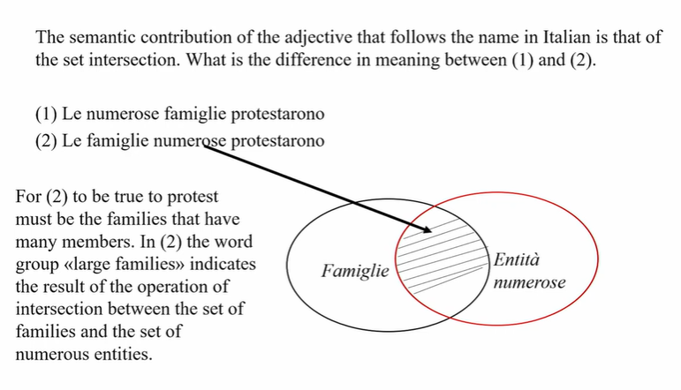

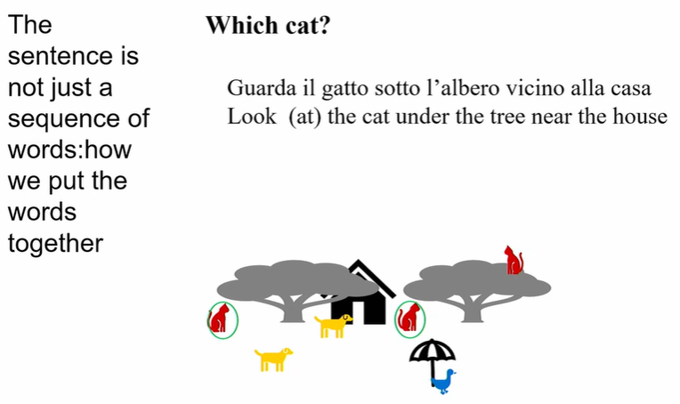
The sentences work perfectly in Italian and English but they are ambiguous. Which cat? there are two possible cats

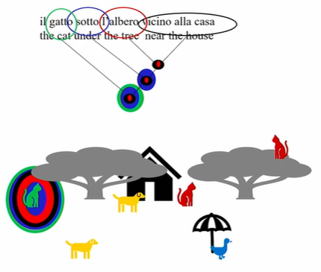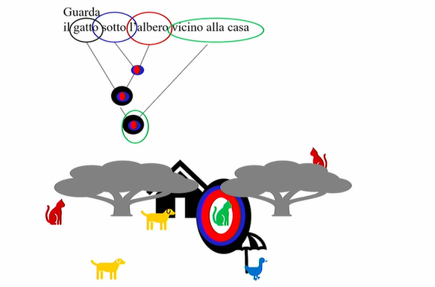

put together the different sets of words and you combine it. Two possible representations

- Near the house attached to the tree
- Near the house attached to the cat

there are some possibility to eliminate the ambiguity with intonation and with context, but a natural language system does not necessary have context and have to still deal with ambiguity sometimes

There are sentences in Italian that are potentially ambiguous and only the context can disambiguate.

Linguistic and natural language processing have to deal with ambiguities. You have systems that deal in this situations.

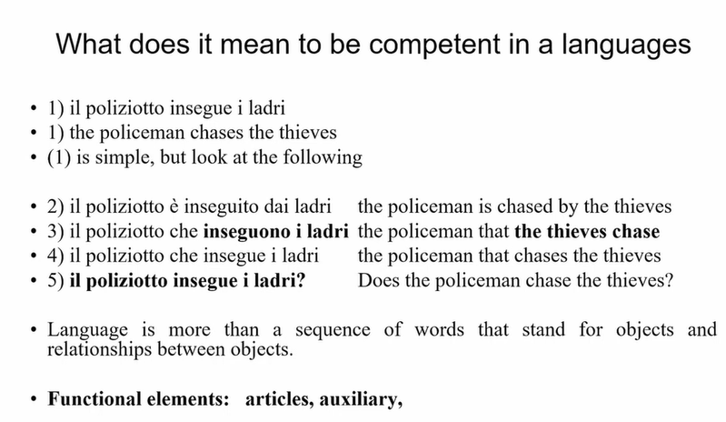
in italian: the subject can follow the verb, is not a property of english

the sentence (5) have exact same word order of (1), you can only know it is a question
- if it is written, you use the question mark (?)
- if it is spoken, you use different tonalities

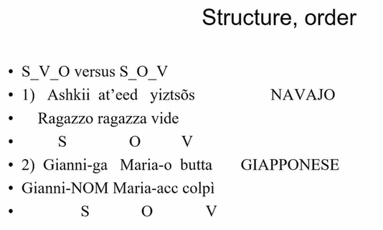
italian, french, english, mandarin… have these order. S(ubject) V(erb) O(bject) as default

order is not something that concern only subject, verb and object. It concern other categories too. In japanese you have seen that the object preserve the verb and noun perceive the preposition
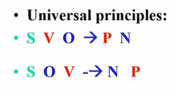
there are variation in the language in the order and there seems to be some universal principle that
- if you are a language with S-V-O order, you are also a language with P-N order (preposition noun order)
- if you are a language with S-O-V order, you are also a language with N-P order (noun preposition order)

the variation is not arbitrary, there is a certain consistency within the language (but there are also exceptions)

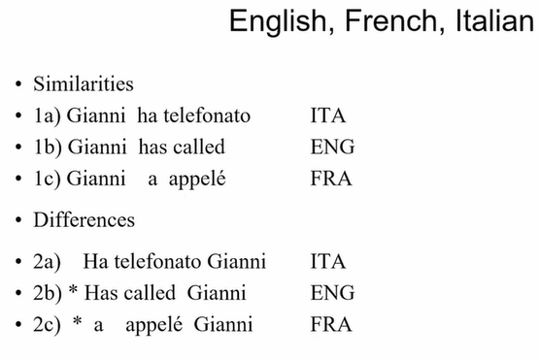
in italian the subject can stay in the postverbal position, but this is not possible in english and french

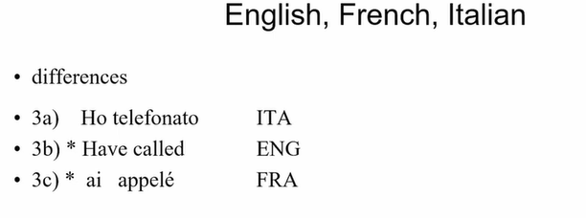
another difference is that in italian we can drop the subject (if the context allow it)

without the subject you can still understand that I refer to myself, I can not do the same in english or french (even if the verb change person per person) is not just a matter of inflection

in mandarin there is no inflection (all verbs are like call) but you can still drop the subject

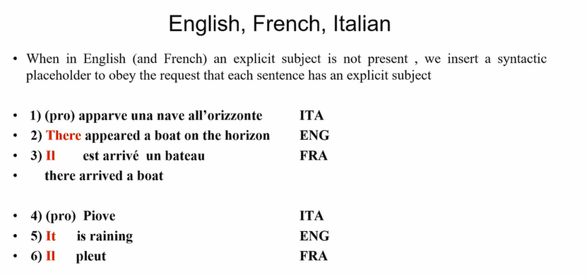

english, french: when the subject is not present, in english I have to insert something because every sentence in english must have some subject, even if it does not do anything. You always need to express the subject (either a pronoun or a place holder)

in italian we can and something must drop the subject. there is no subject we can put in front of rains.

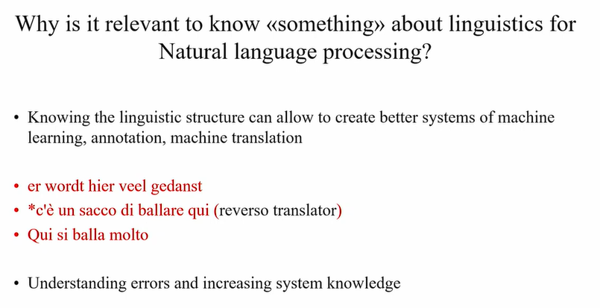
knowing something about the linguistic structure can allow to create better system of ML and annotation and for machine translation

the translation is an impossible sentence (c’è un sacco di ballare qui) in italian, the accurate translation would be qui si balla molto.

understanding this error is useful because I could increase the knowledge of the system and avoid it to making an error

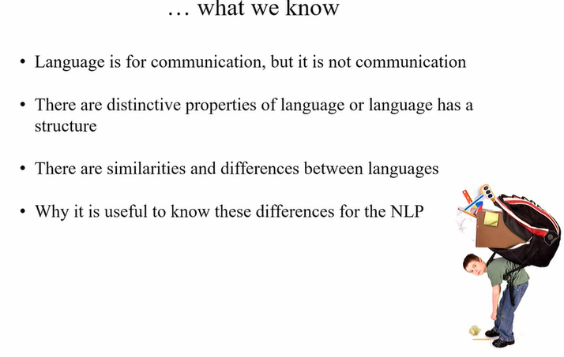

Some problems and facts about linguistic useful for natural language processing

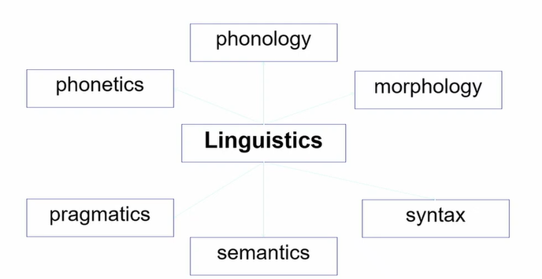
different domains and linguistic

From sound to messages
languages conveys messages starting from sound or signs (there are also sign languages)

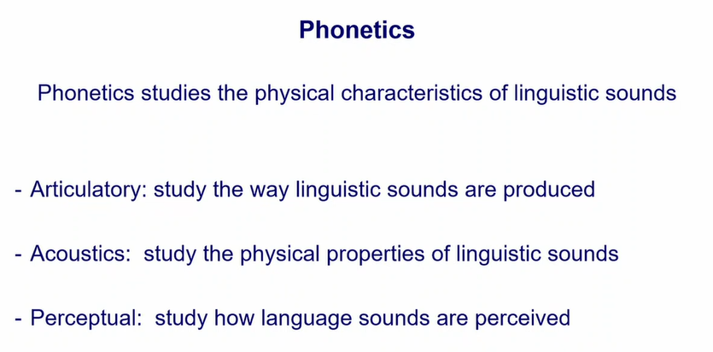

phonetics: studies the physical characteristics of linguistic sounds, the sounds that are present in the languages of the word, we have many sounds that are not present in a language but are present in another language

we can study this sound in three ways
- articulatory: study how the vocal fold is organized in order to produce a certain sound (where is your tongue with respect to the teeth)
- acoustic: you study the physical property of the sound, you obtain spectrogram
- perceptual: how we human perceive the sound

when we are infants we are able to discriminate all sounds present in the world, not for all sounds. However at 12 months we become deaf to certain sounds (r and l in chinese, there is no distinction in cheese)

when we become speaker of a language we focalize only on the sound relevant in our system

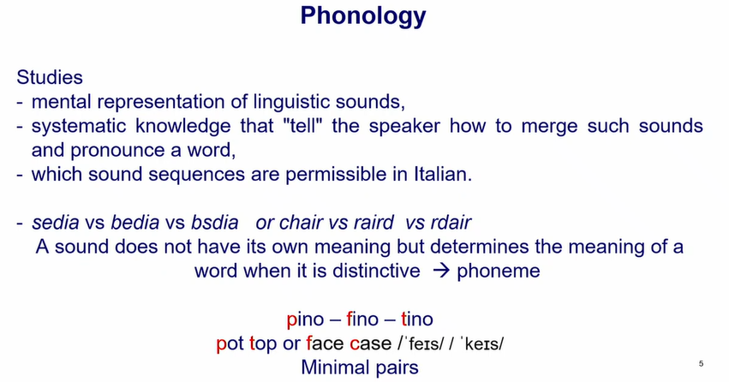
phonology: mental representation of linguistic sounds.

pino, fino, tino. change only the first sound (phoneme), other 3 are the same

Phoneme: something that distinguish the meaning of words. A sound that does not have it own meaning but determine the meaning of the word when it is distinguished. What are the phonemes in the language and how speakers merge sound

when you search for phonemes you don’t look at the ortophtphy (Face ≠ Case) you have to look at the sound (similar sound). In italian, orthography is transparent but there are some cases in which the orthography is not transparent, pay attention to the sound. It studies also the fact that you can create new words (but have to respect phonological rules and the combinatioaria rules of the language)

phoneme are in our mind, not the same for another native speaker of another language

phonology: what are the phoneme in the given language and how speakers merge sound to pronounce a word. Cover the intonation and rhythm of language too. The unit is the phoneme

Phoneme: mental representation that have a distinctive feature. To see what is a phoneme you check minimal pair, sequence of sounds that differ from one sound only

phonology: study the sound that are in a language and have a distinctive feature for that language and how you combine that sound in this particular language
phonetics: how the sound are produced, what is the physical shape regardless of they are instantiated (?)

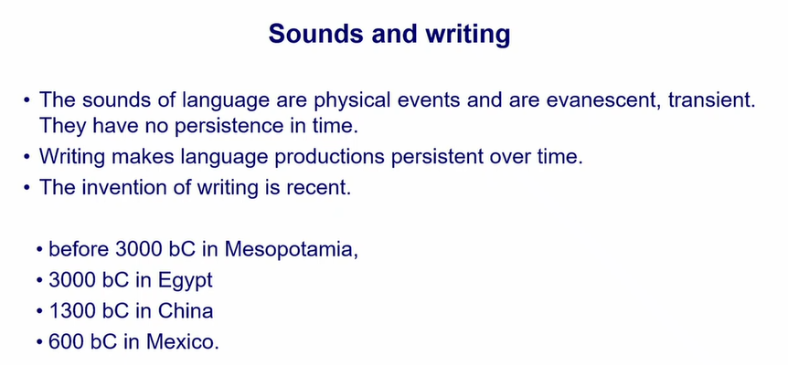

courtaiculation: the way you pronounce a certain sound depends on the next voule.

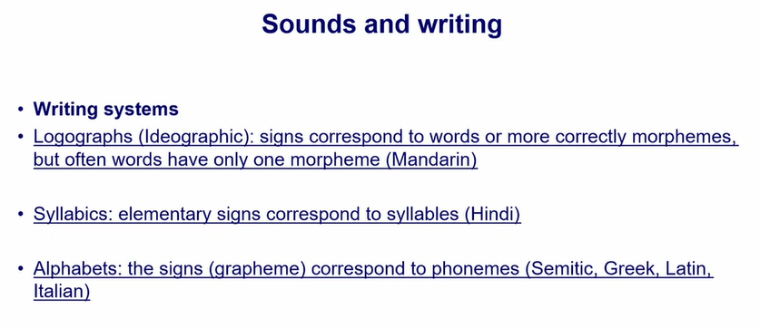

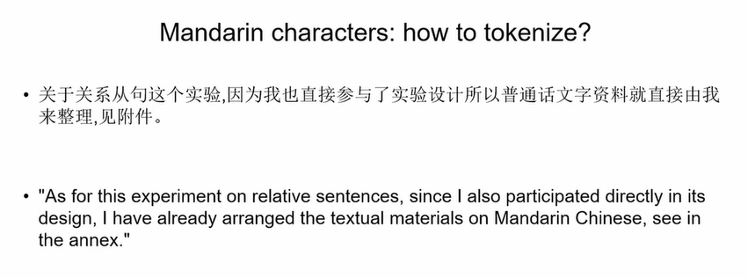

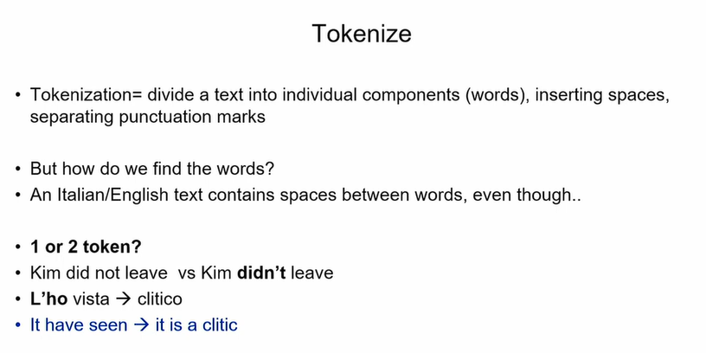
first thing is to tokenize: find a word

no spaces

what is tokenize: divide a text into individual components (words). Insertion spaces, separating punctuation marks

classifier: are similar to an article but can have semantic meaning

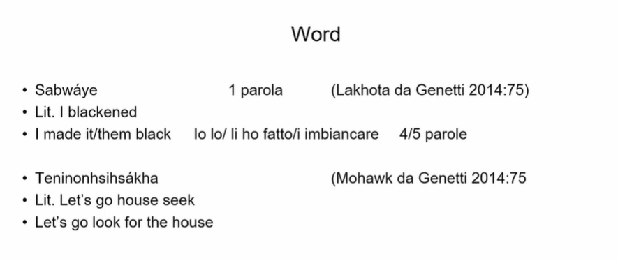
What we call a word may vary depending on the language. Sabwaye (from native american) if you want to translate in italian or english I would translate in 4 or 5 words.

Translations have to take into account this, you can not do a literal translation. The literal translation is not good, you must understand the meaning and then do a translation

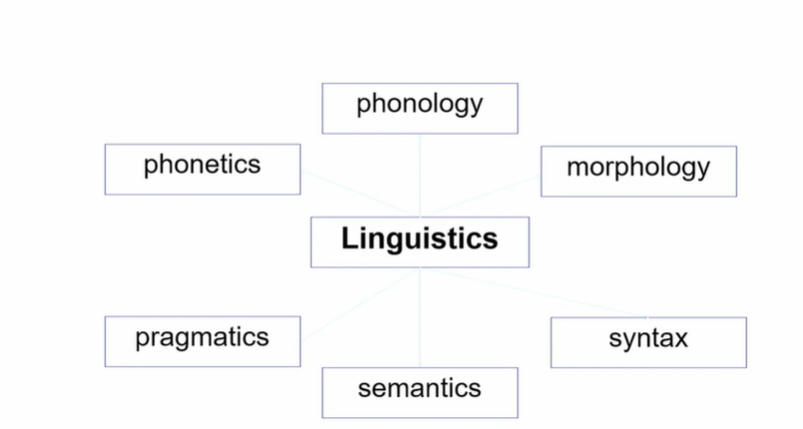

Morphology
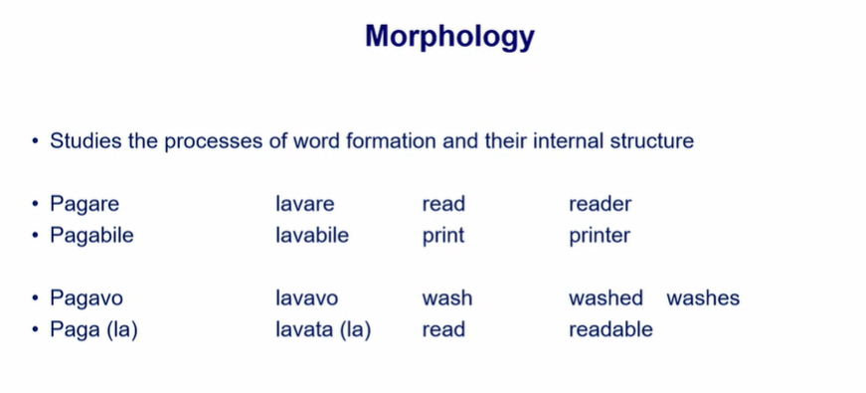

Morphology: study the processes of word formation and their internal structure.

Verb: pagare (pay) lavare (wash) from the verb you can have an adjective (pagabile, payable) or (lavabile, washable).

Read (verb) you can obtain reader (the person who does the action described by the verb).
Print (verb) ⟹ printer (the object that does the action of printing)

Process of morphological word formation. You can obtain from the basic form an adjective or a noun

Morphology is about the fact that you can have similar word with the same base and that from a base form you can derive other forms that can have different meaning or that add something to the meaning of the base

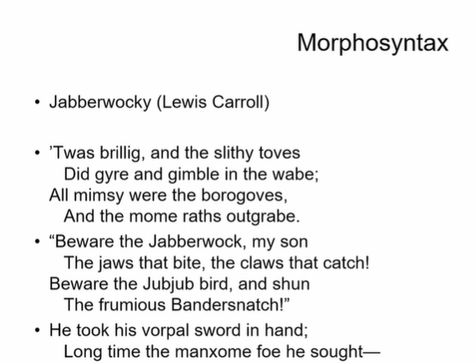

Morphosyntax
Poem in english by Lewis Carroll

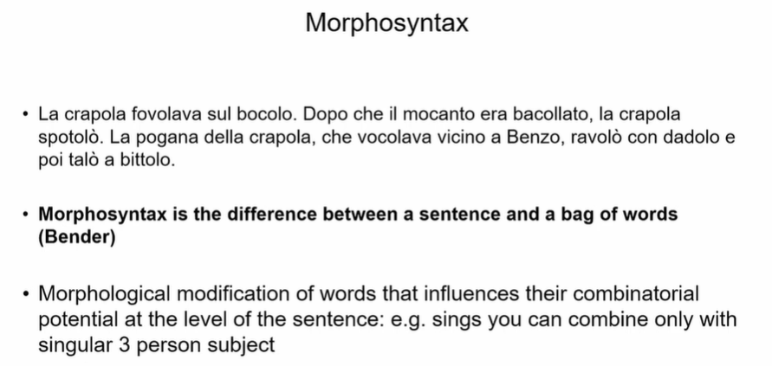

If I start invent new words could this be a set of grammatical correct sentence in italian

is formally good english but does not have a meaning. Something that does not have a meaning, the objects and verb does not refers to an action, they are invented. But this could be a good set of sentences.

Morphosyntax is the difference between a sentence and a bag of words
Bag of words: words put together without any structure. Here you have a structure, you have some words that are real words in italian that do not have a meaning by itself but they
contribute to meaning

these words tell you something about the structure of the sentence, these words is what morphosyntax care about

Morphosynatax care about the modification of words that have an influence on their combinatory potential at the level of sentence. sings can only combine to a third person he, she. can not say they sings.

In italian when you have a noun that is femminile and you infer this you have a femminile article.

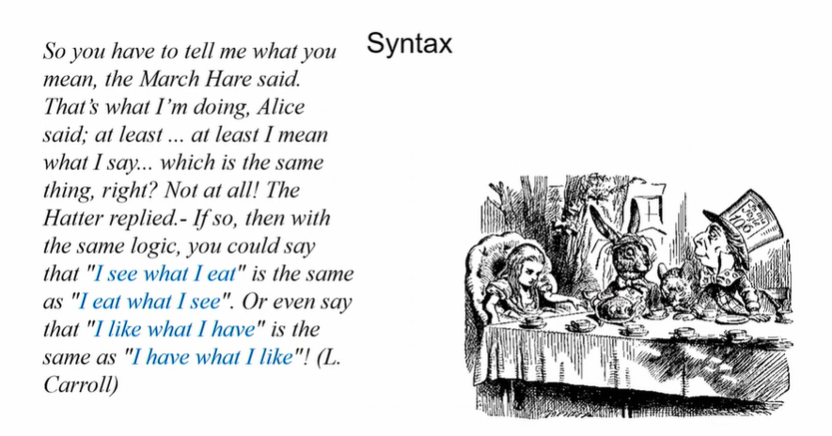

Syntax

even if you have same words, if you put them in a different order it conveys different meaning

syntax care about the way you put words together and the order of word

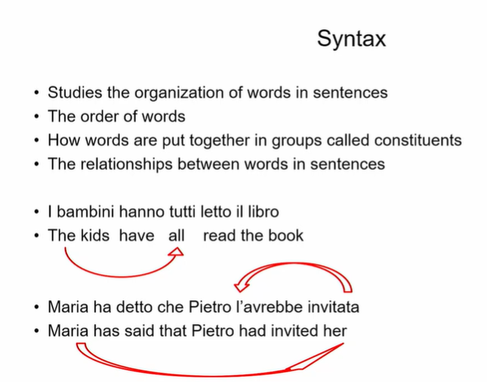

syntax studies the organization of words in sentences and how words are put together in groups called constituents.
There are relation between words in a sentence.
The kids have all read the book the word the kids and all are together, even if they are separated by the word have.

Syntax have to do with this dependence of words that can not be adjacent.

Maria has said that Pietro had invited her.
Her ⟹ maria

In italian is different, the pronoun is not after the verb, but is before. The pronoun does not show the gender, you can see the gender on the past participle invitata.

A natural language system have to take this into account because you have dependents that are spread in the sentences and are not adjacent

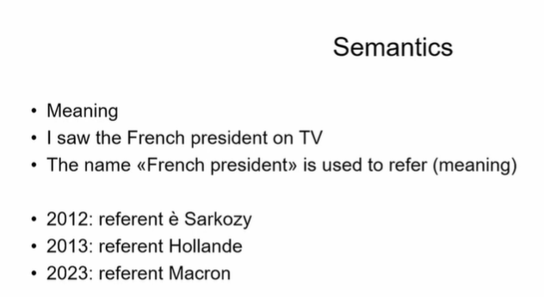

Semantics have to do with meaning. If I say I say the french president on TV the name french president have a meaning, but the referent vary depending on the year I said the sentence

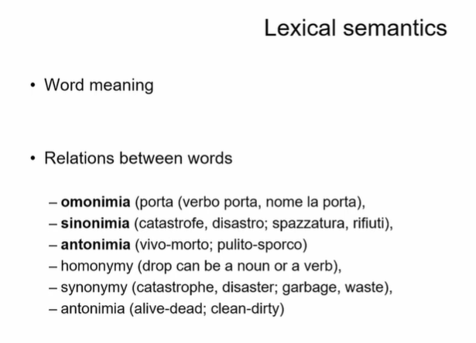

Semantics deal also with word meaning and relation with the words
omonimia: the word porta can be a verb (carry) or a noun (door). Something that have the same sound but different meaning
sinonimia: words that different in sounds but have (more or less) the same meaning
antonimia: couple of words that are one the opposite of the other

words can have relation between them

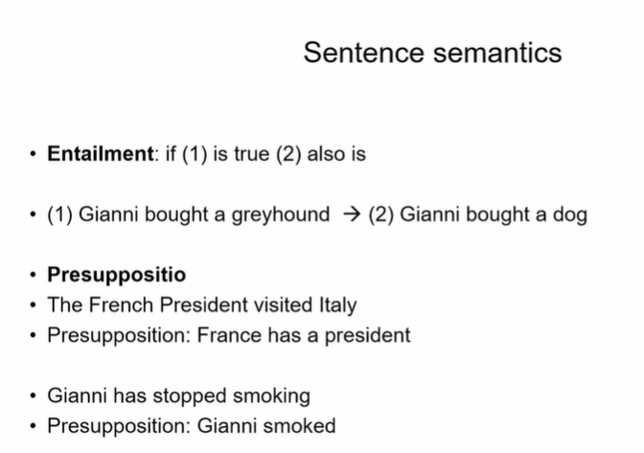

sentence semantics: has to do with the truth of sentences or relation between sentences
entailment: if (1) is true, also (2) is true

if gianni bought a greyhound then gianni bought a dog

Presuppositio: something presupposes something else
The french president visited italy pressuposed that french has a president

sentence sametings cares about the truthfulness of the falsity of the sentences and relationship between sentences (like entailment and presupposition)

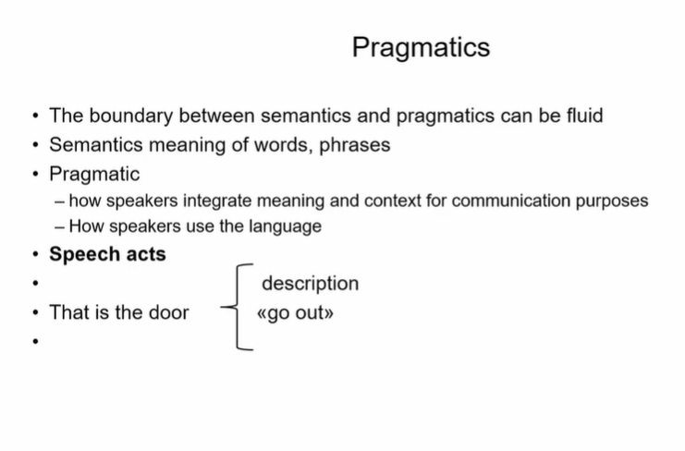
pragmatics
not clear boundary between semantic and pragmatics

semantics: care about the meaning of words and sentences
pragmatics: how speaker integrate meaning and context for communication purpose

same sequence, depending on the context, can have different meaning

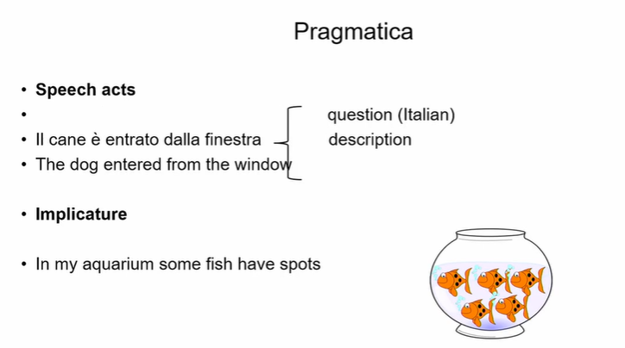

speech acts

implicature:
not some fish but all the fish

it would be more appropriate to say that all fish have spots

when you ear some fish have spots you make an infenrece that in the aquarium there is at least one fish without the spots.

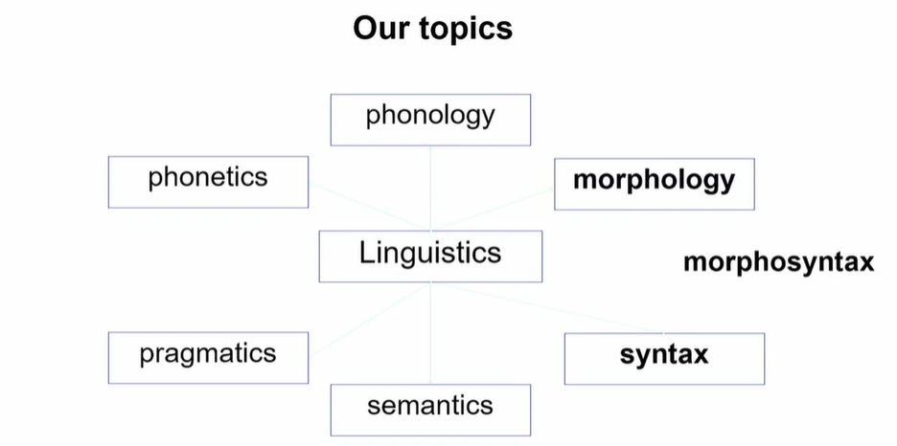

there are different domains in linguistic

Morphology and Morphosyantax

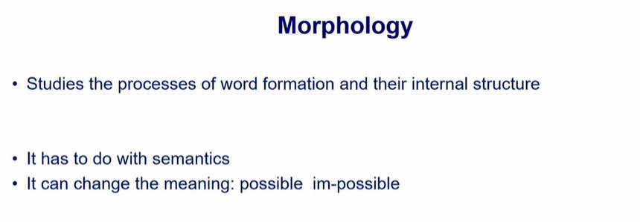

morphology: study of word formation and the study of interal structure of the words

possible if you add im (is a morphomne) you obtain an adjective that has the opposite meaning, same for english and italian

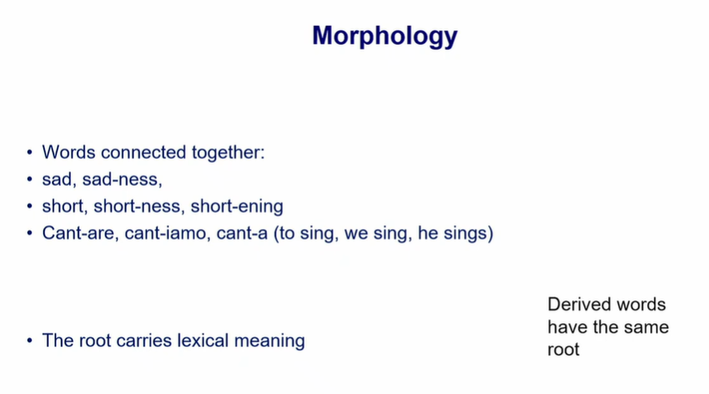

morphology cares about the fact that words are connected among eachother

sad ⟹ we can obtain sadness that is related with meaning

short ⟹ shortness, shortening

cant-are (infinitive), cant-iamo (we sing), cant-a

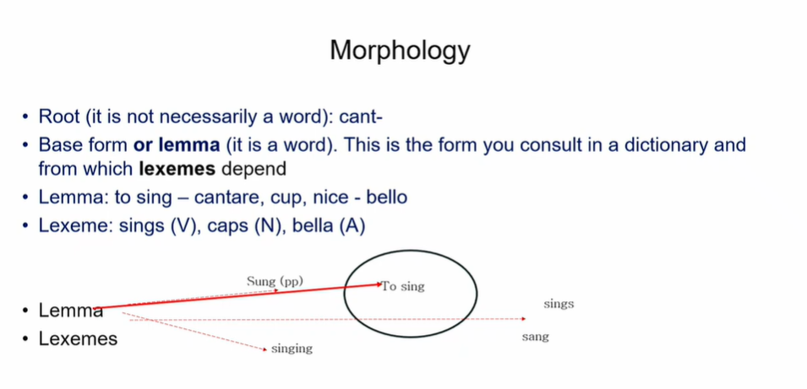

root: not necessarily a word, depends on the language. In italian is generally not a word
base form/lemma: the form that you consult in the dictionary, from which lexemes depends
lexeme: different morphological of the base form

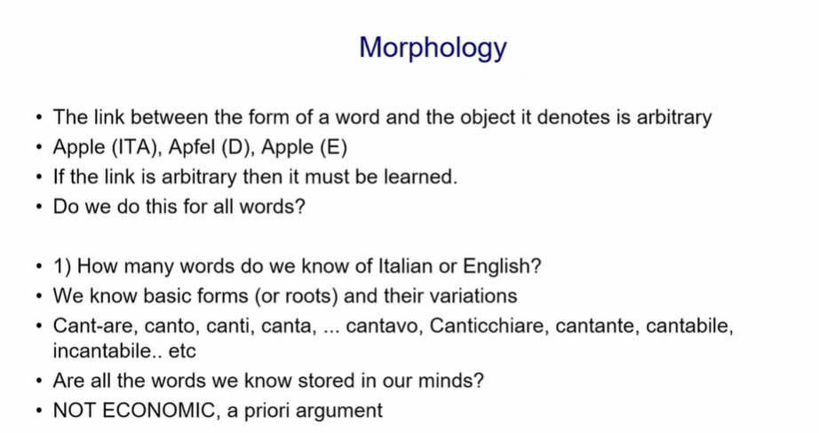
the link between the form of a word and the object it denotes is arbitrary

not economic to know all the possible combinations of a word

are all the words we know stored in our mind? is not economic to do so

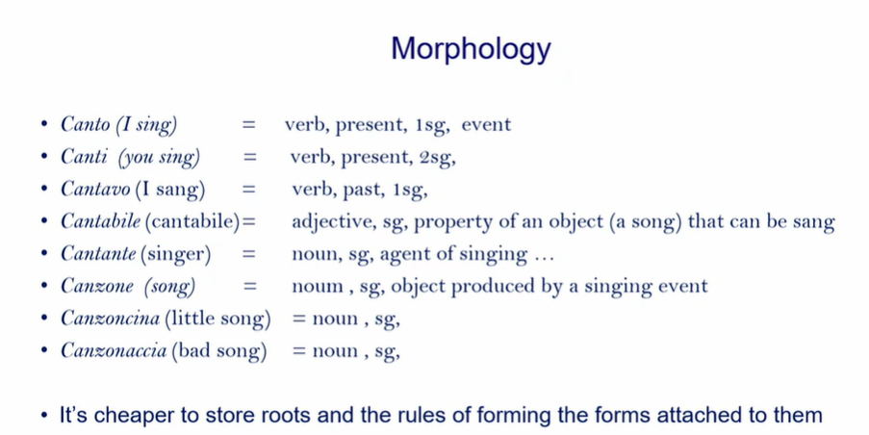

there are commonalities, easier to store roots or basic form (lemma). I have to know the rules

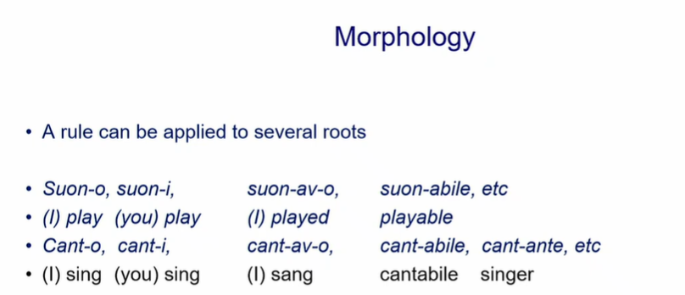

exception have to be learn by hard
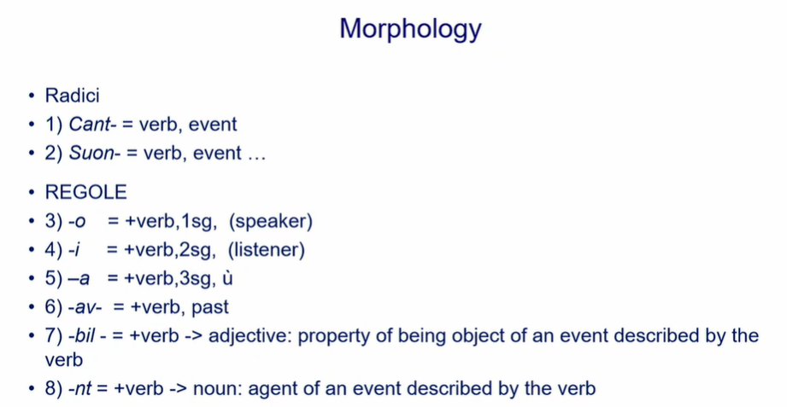

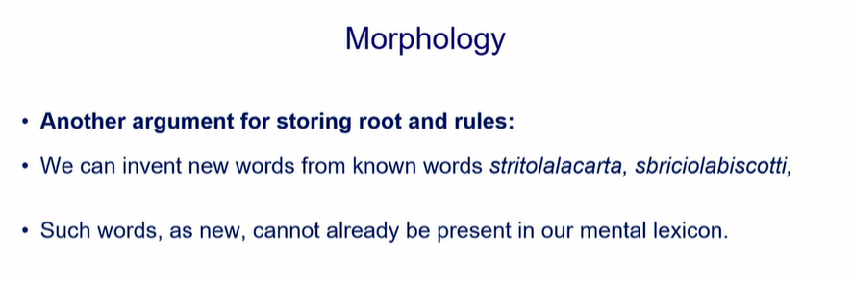

we can invent new words
stritolalacarta and sbriciolabiscotti new words and you can understand them

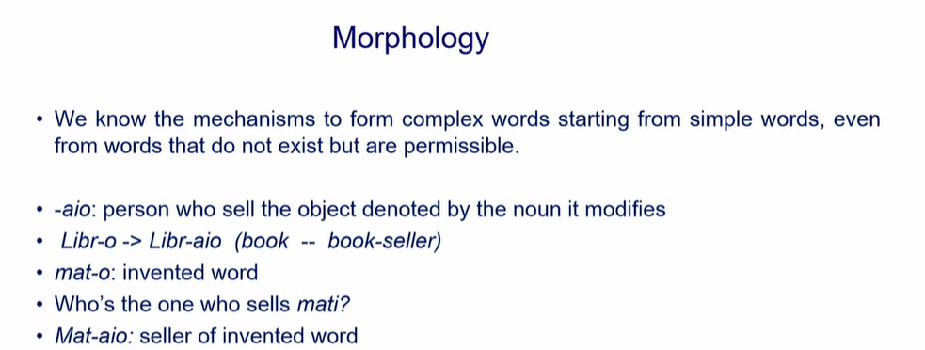

this is why we don’t have everything memorized

the ending have some meaning

-aio. Libro ⟹ libr-aio (the seller)

mato invend word ⟹ the seller whold me mataio
We invent new word to denote new profession

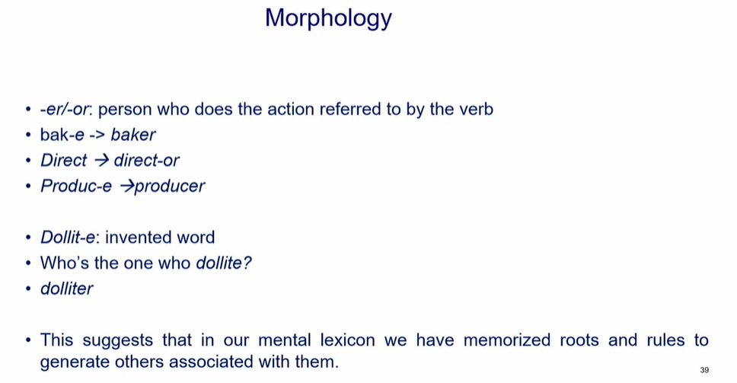
we know this rules of morphology, there are certain pieces that we can add to words (root) to obtain another meaning

in our mental lexica we have memorized root and lemma and rules to generate other words associated to them
no need to memorized everything

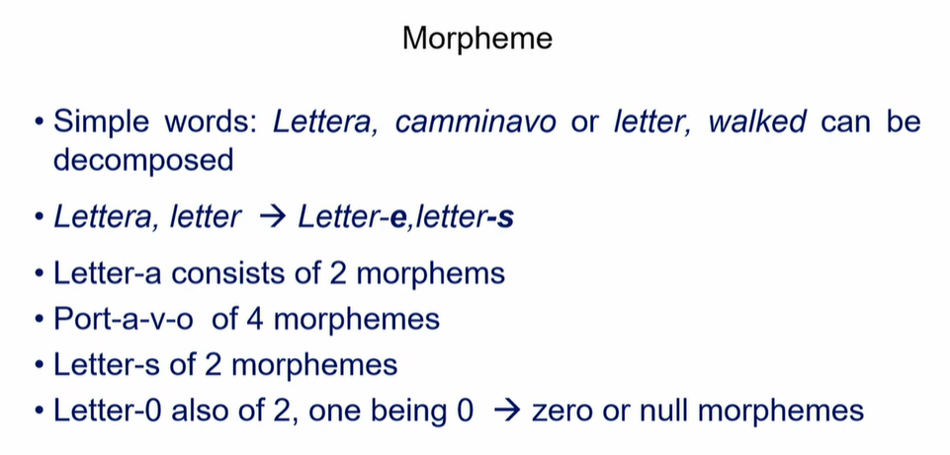

lettera
these words can be decomposed, with different terminals

root-ending

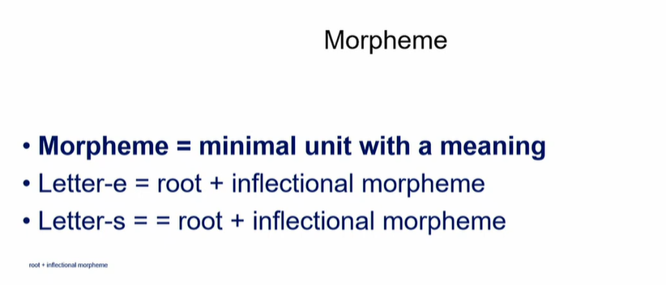
morphine: minimal unit with a meaning

the pieces you add contribute to the meaning of the word, tell if it singular, plural, feminile, maschile…

Phonetics: study the physical characteristic of linguistic sounds

- Articulatory: study the way linguistic sounds are produced
- Acoustics: study the physical properties of linguistic sounds
- Perceptual: study how language sounds are perceived

We focalize only on the sounds revel to our system

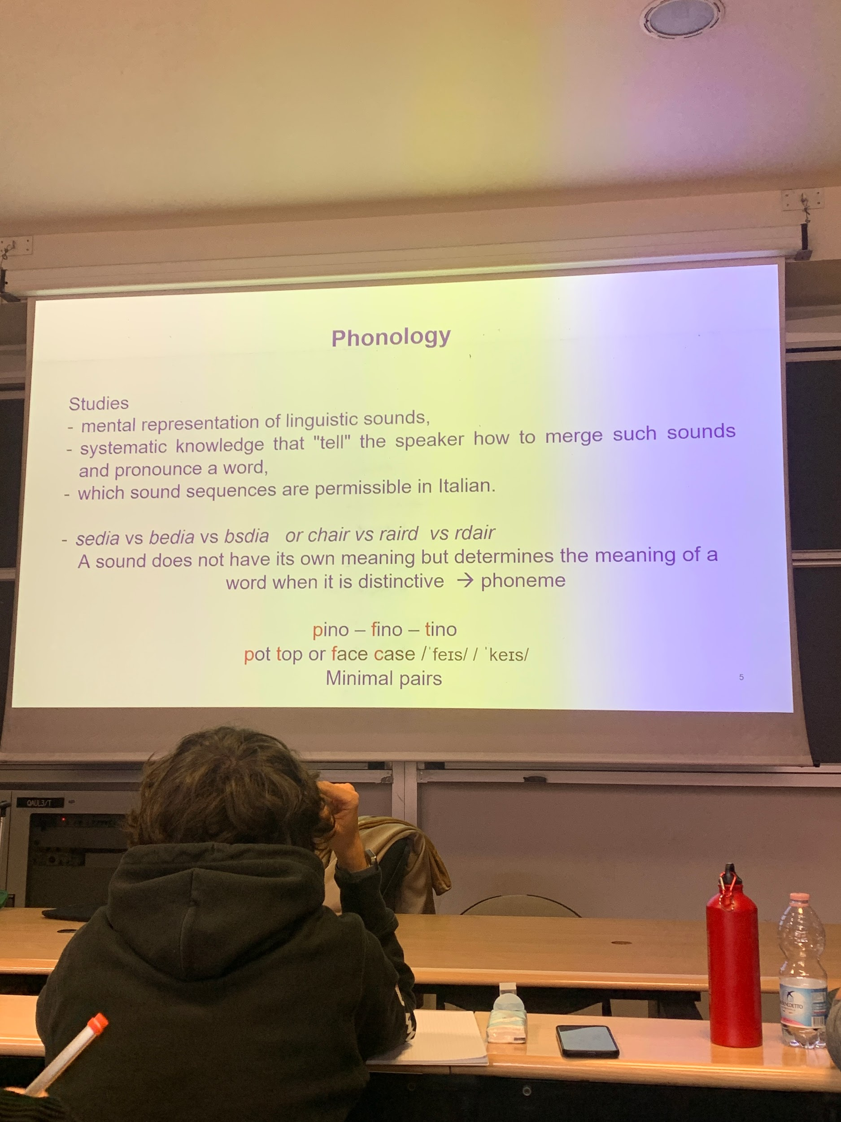

from phonetic transcription is similar in terms of sounds, don’t look on ortographic but instead on how is pronounce.

Italian orthography is transparent, there are some expecpetion

phoneme are in our mind

phonology: what are the phoneme in the langnuge, how speakers merge sounds to pronounce words. studies also that you can invent new words but you need the respect pof the phonotactics rules.

sedia: well known word
bedia: invented word but is perfect italian word (same for raird in english)
bsdia: not possible word in italia (same for rdair in english)

phonology and phonetics are useful in speech processing or when produce oral language from text.
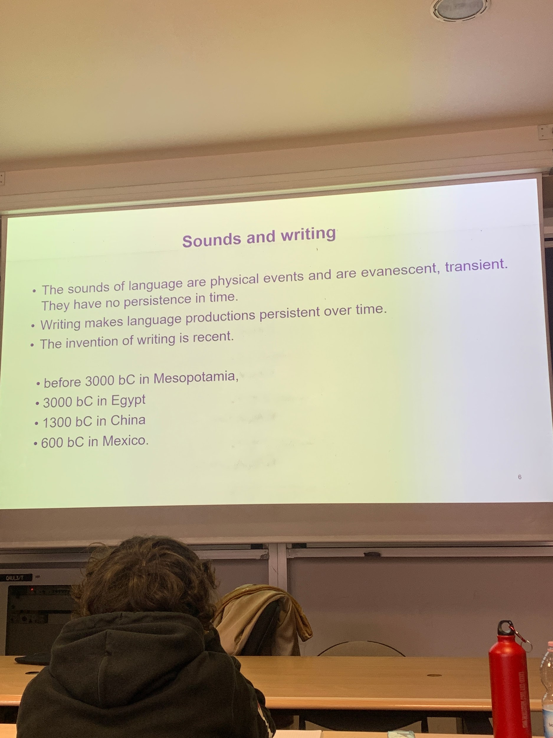

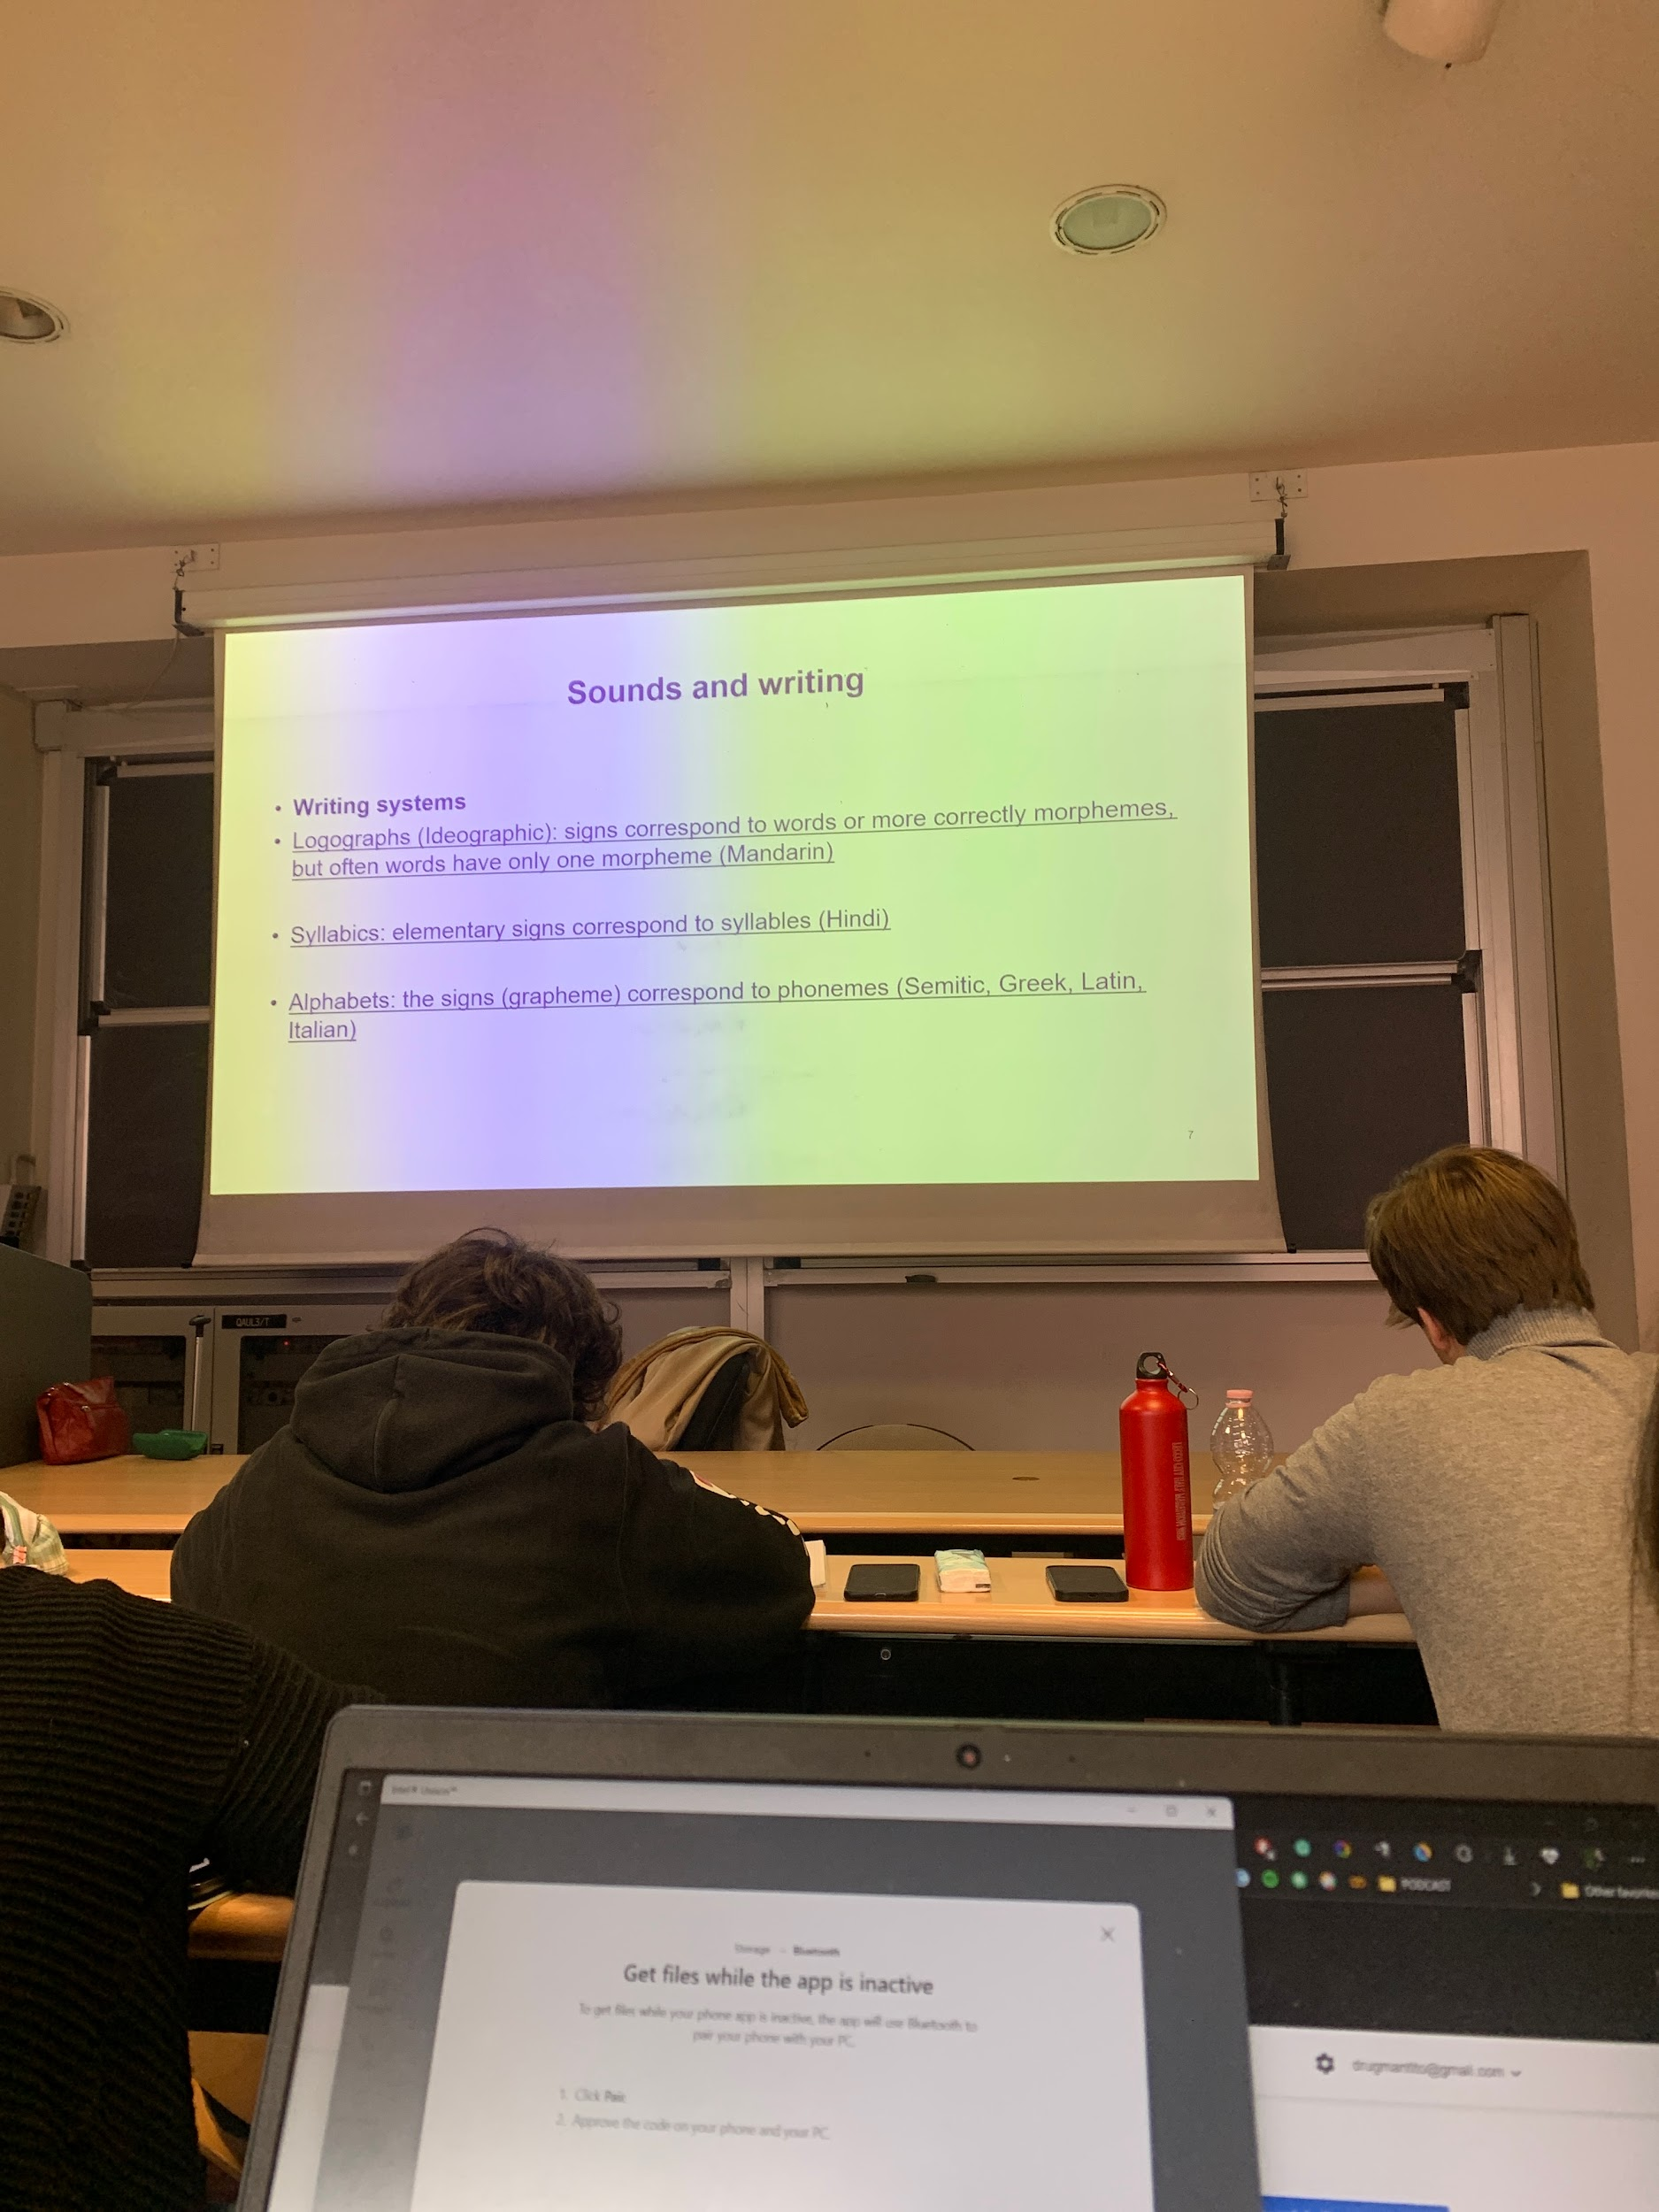

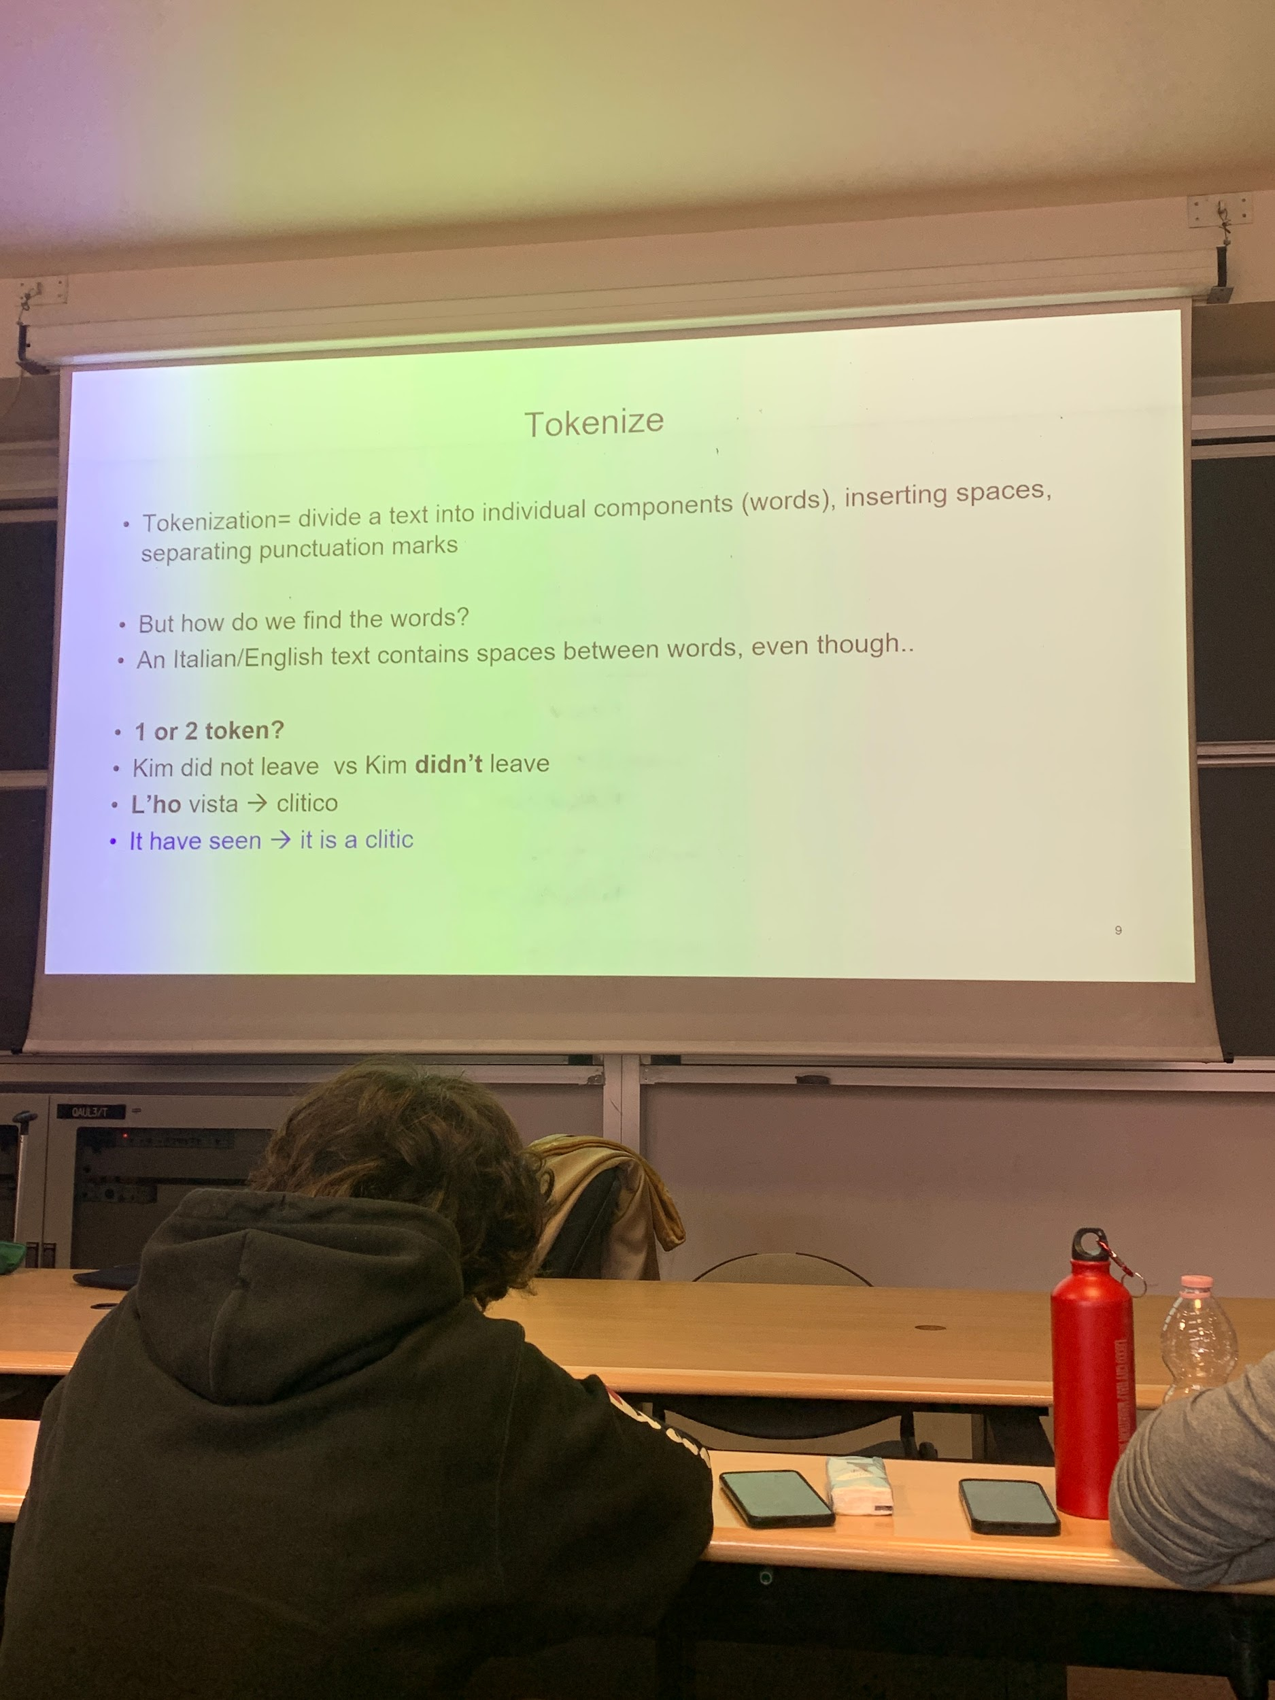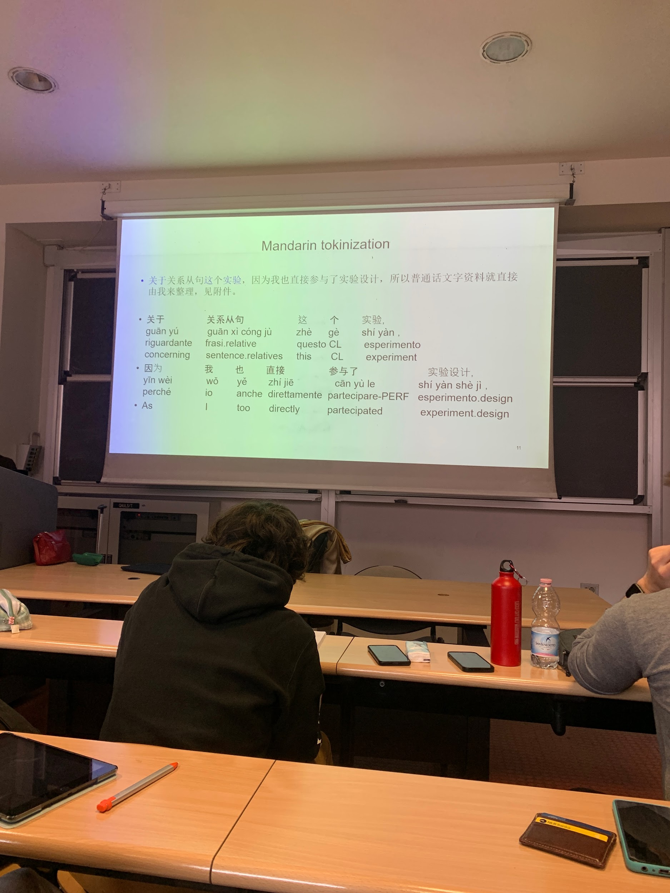

same pronunciation used for the terminal.

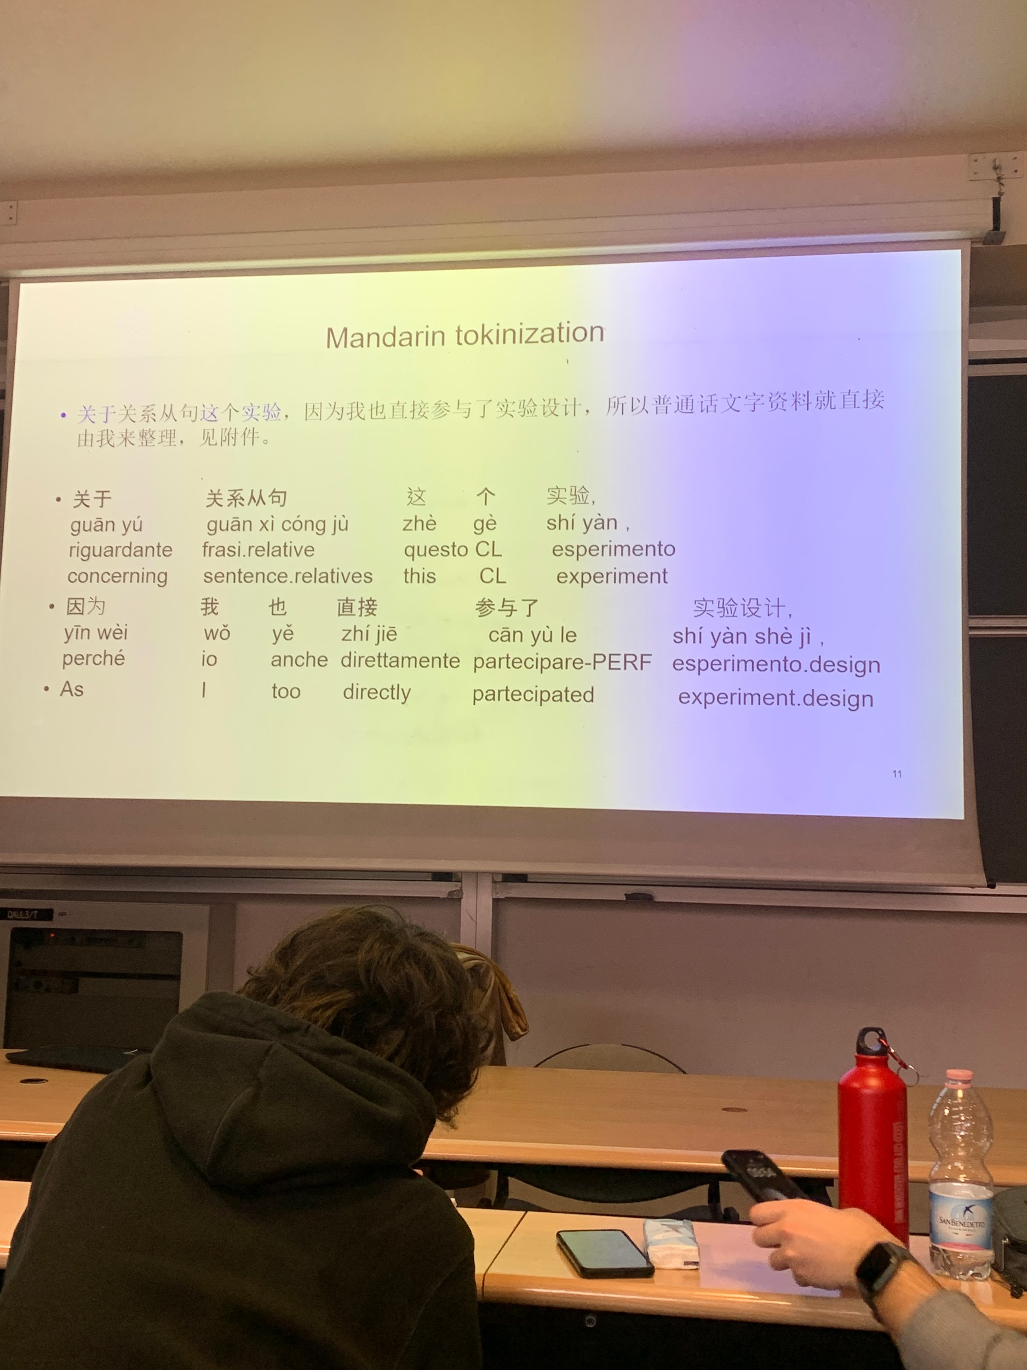
classifiers are somethinglike an articole but is noit an article, have some semantic meaning

different words you don’t see

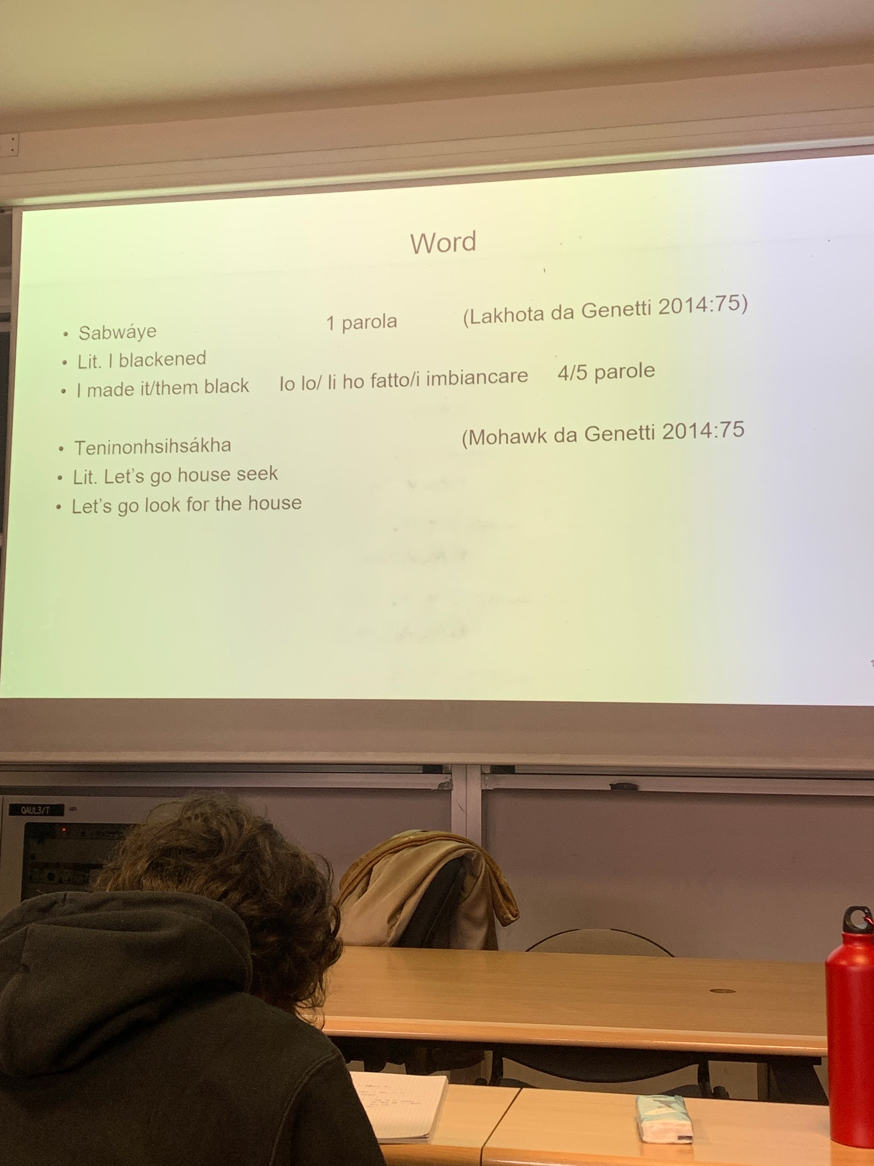
notion of words, but these notion may vary depending on the language.
lakhota language spoken by american native.
subway = 4 or 5 words in italian

words are not the same thing in all the languages,

mohawk another language spoken by american natives
1 word = more words in english and italian

translation have to consider this, you can not do a literal translation (I blacened) you have to understand the meaning and do the translation.

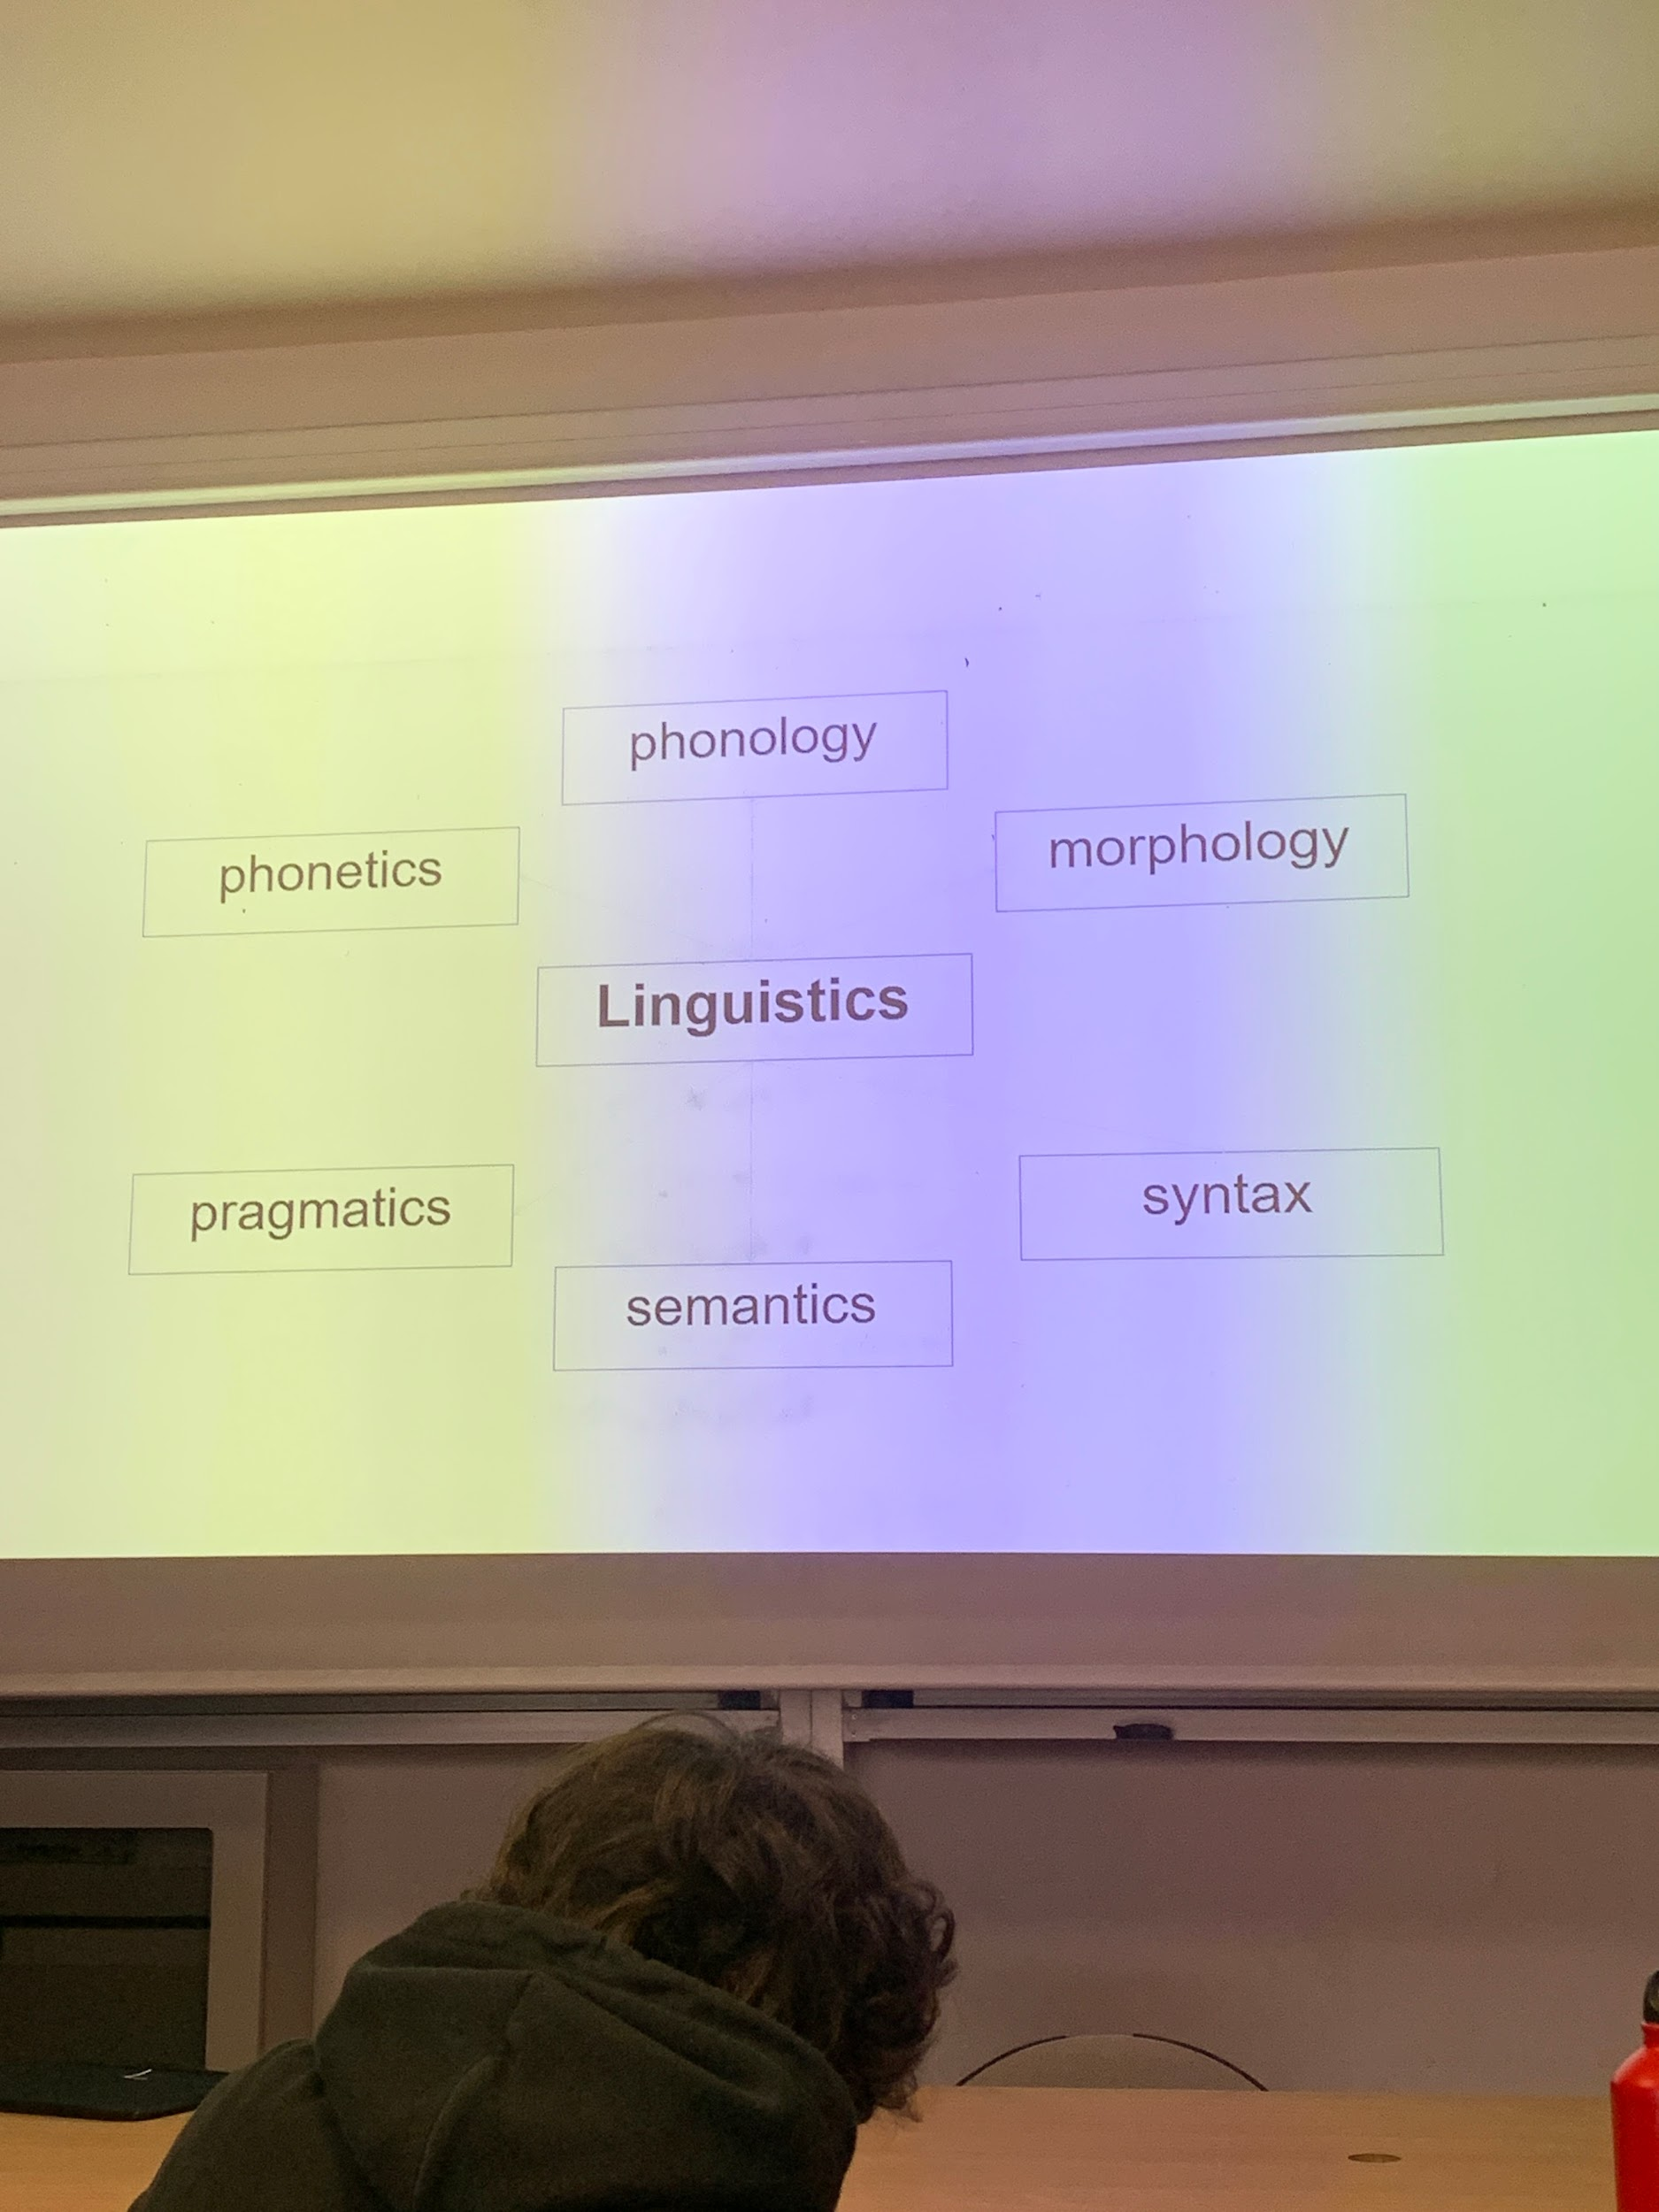

---

same words in different order can have different meaning, syntax is important. I see what I eat / I eat what I see

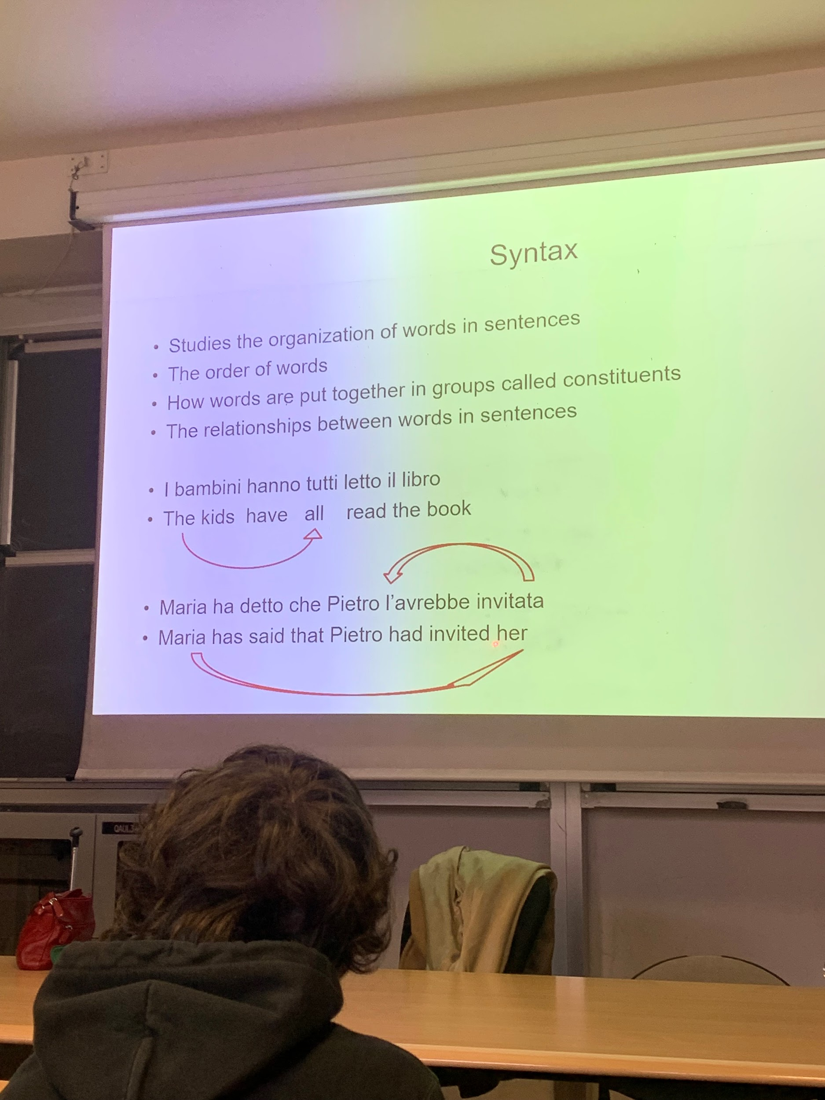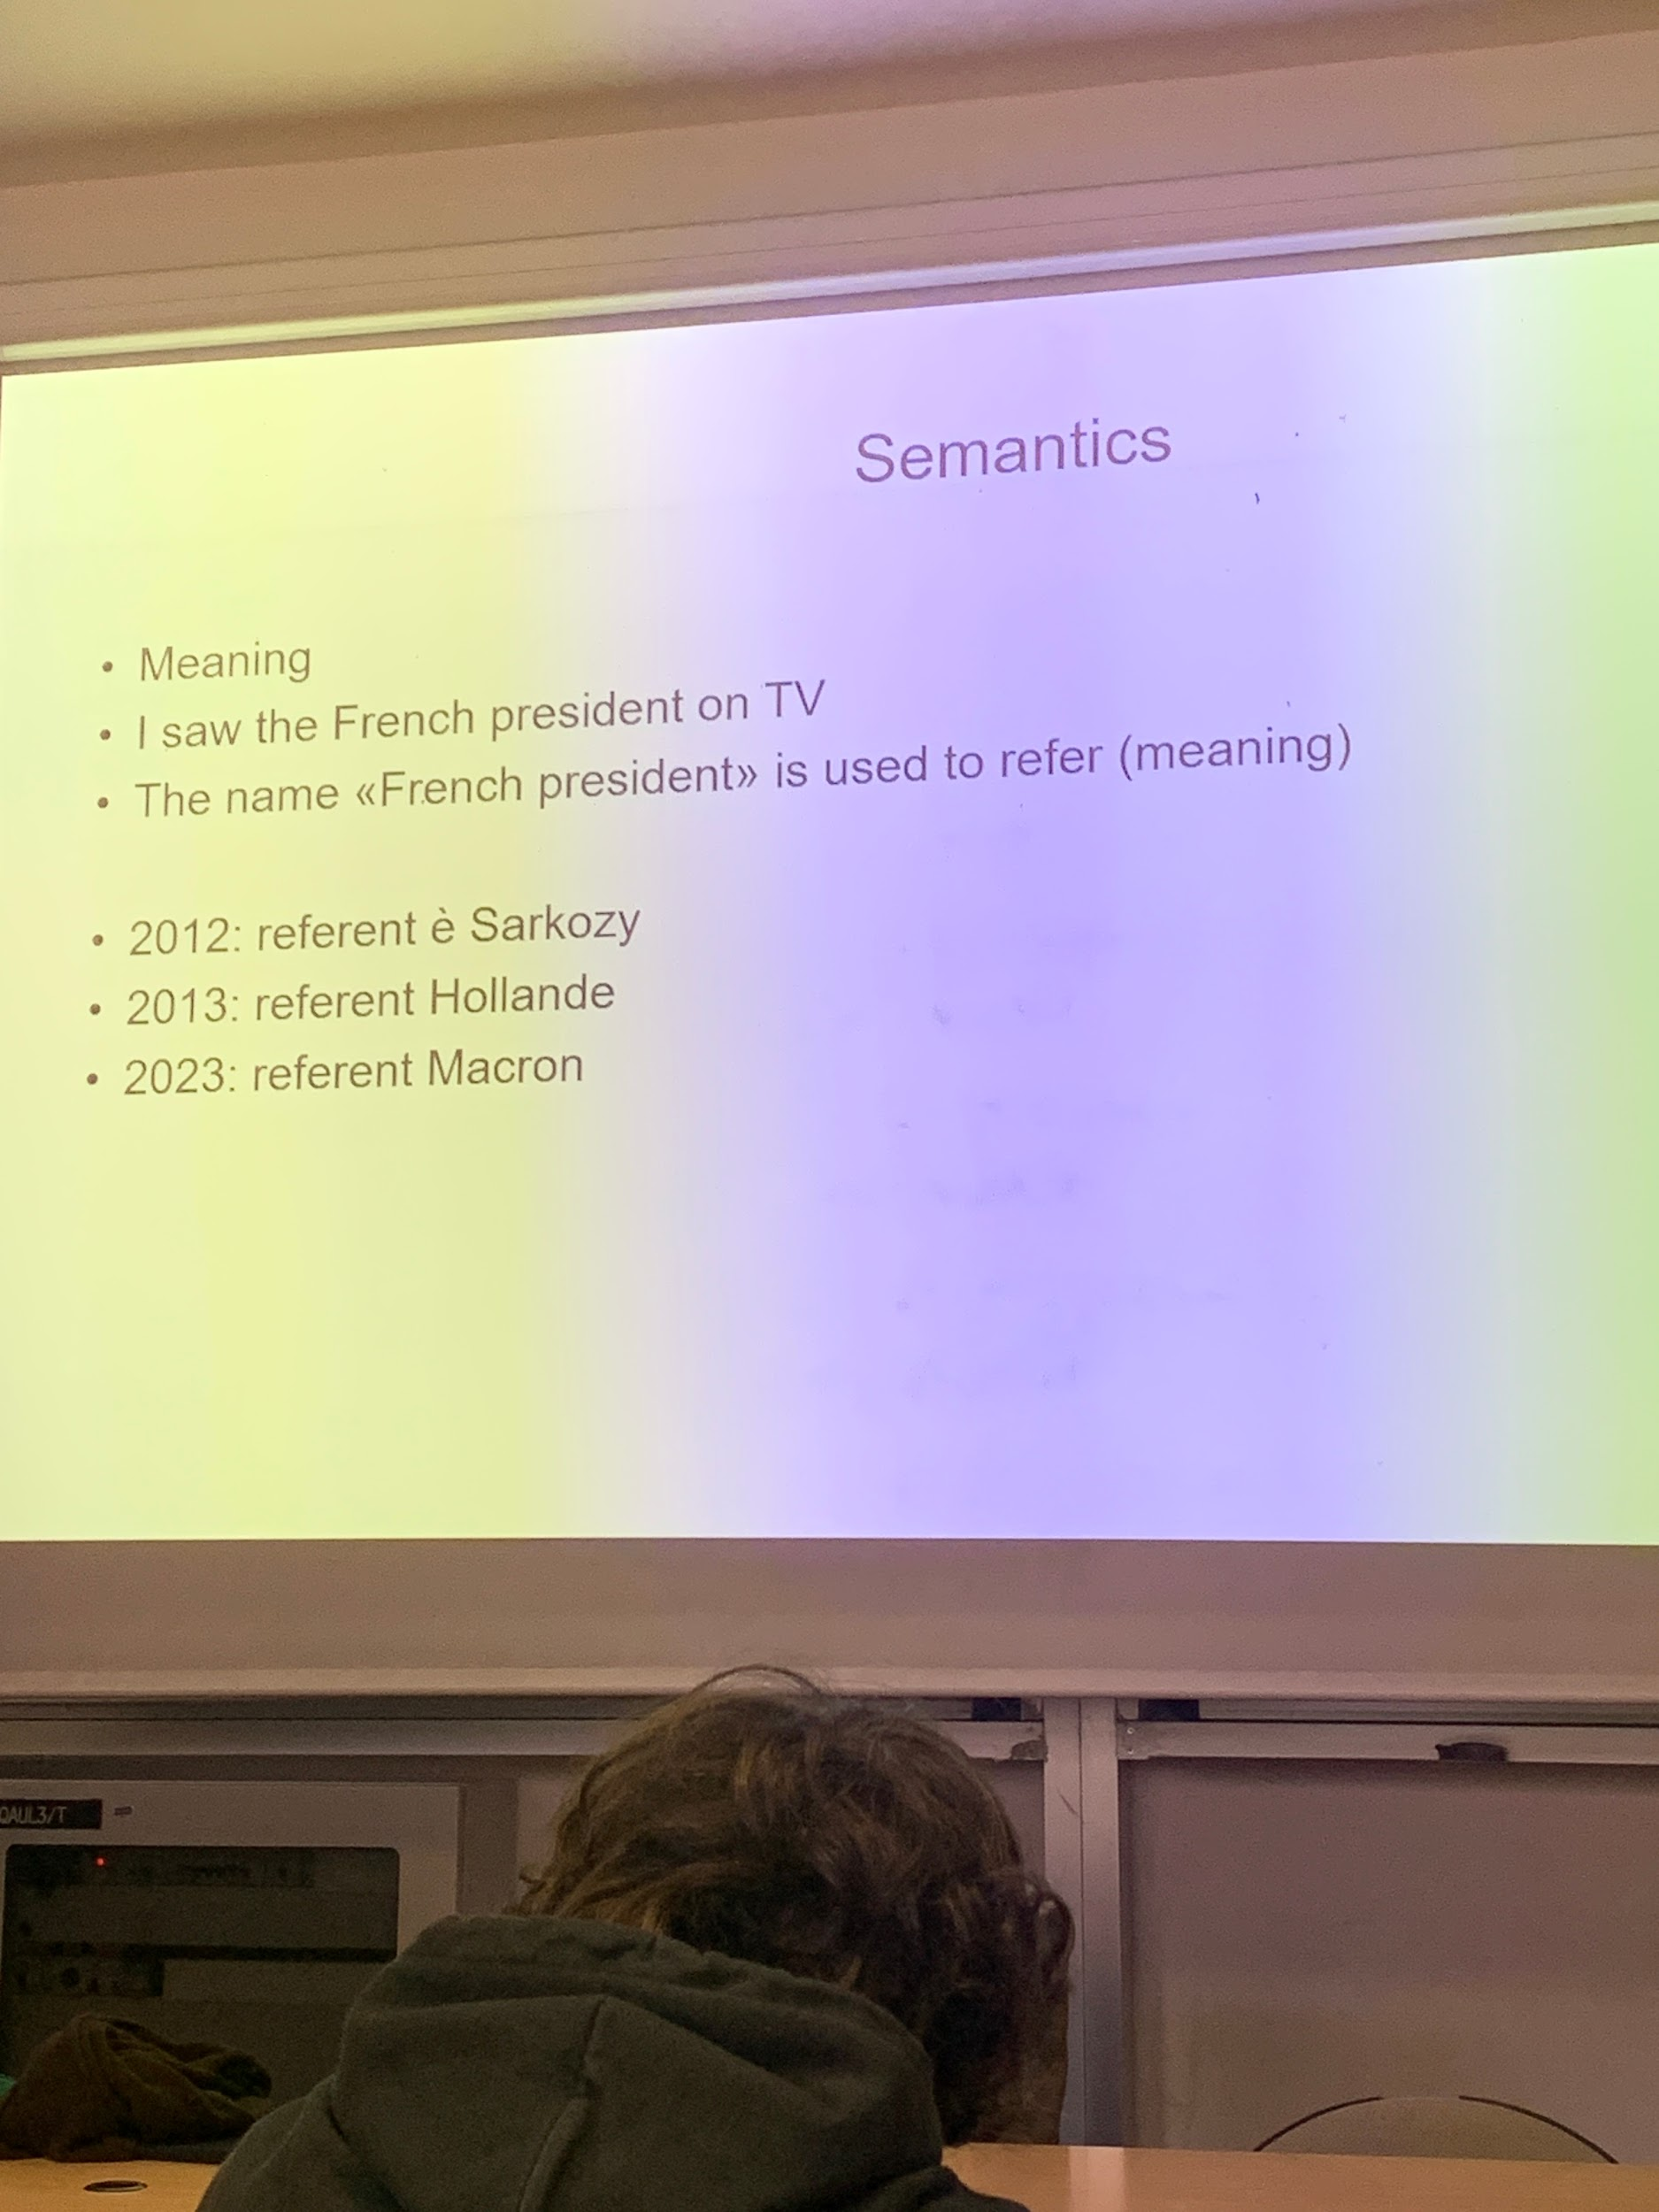

syntax study the organization of words in sentences, how they are put together in groups called costituent

pronouns does not show the gender. there is a relation between avrebbe and invitata. you hae dependences that are spread in the sentences.

french president have a meaning, but the referent mvary depending on the year I said the frase, the referent changed over the year

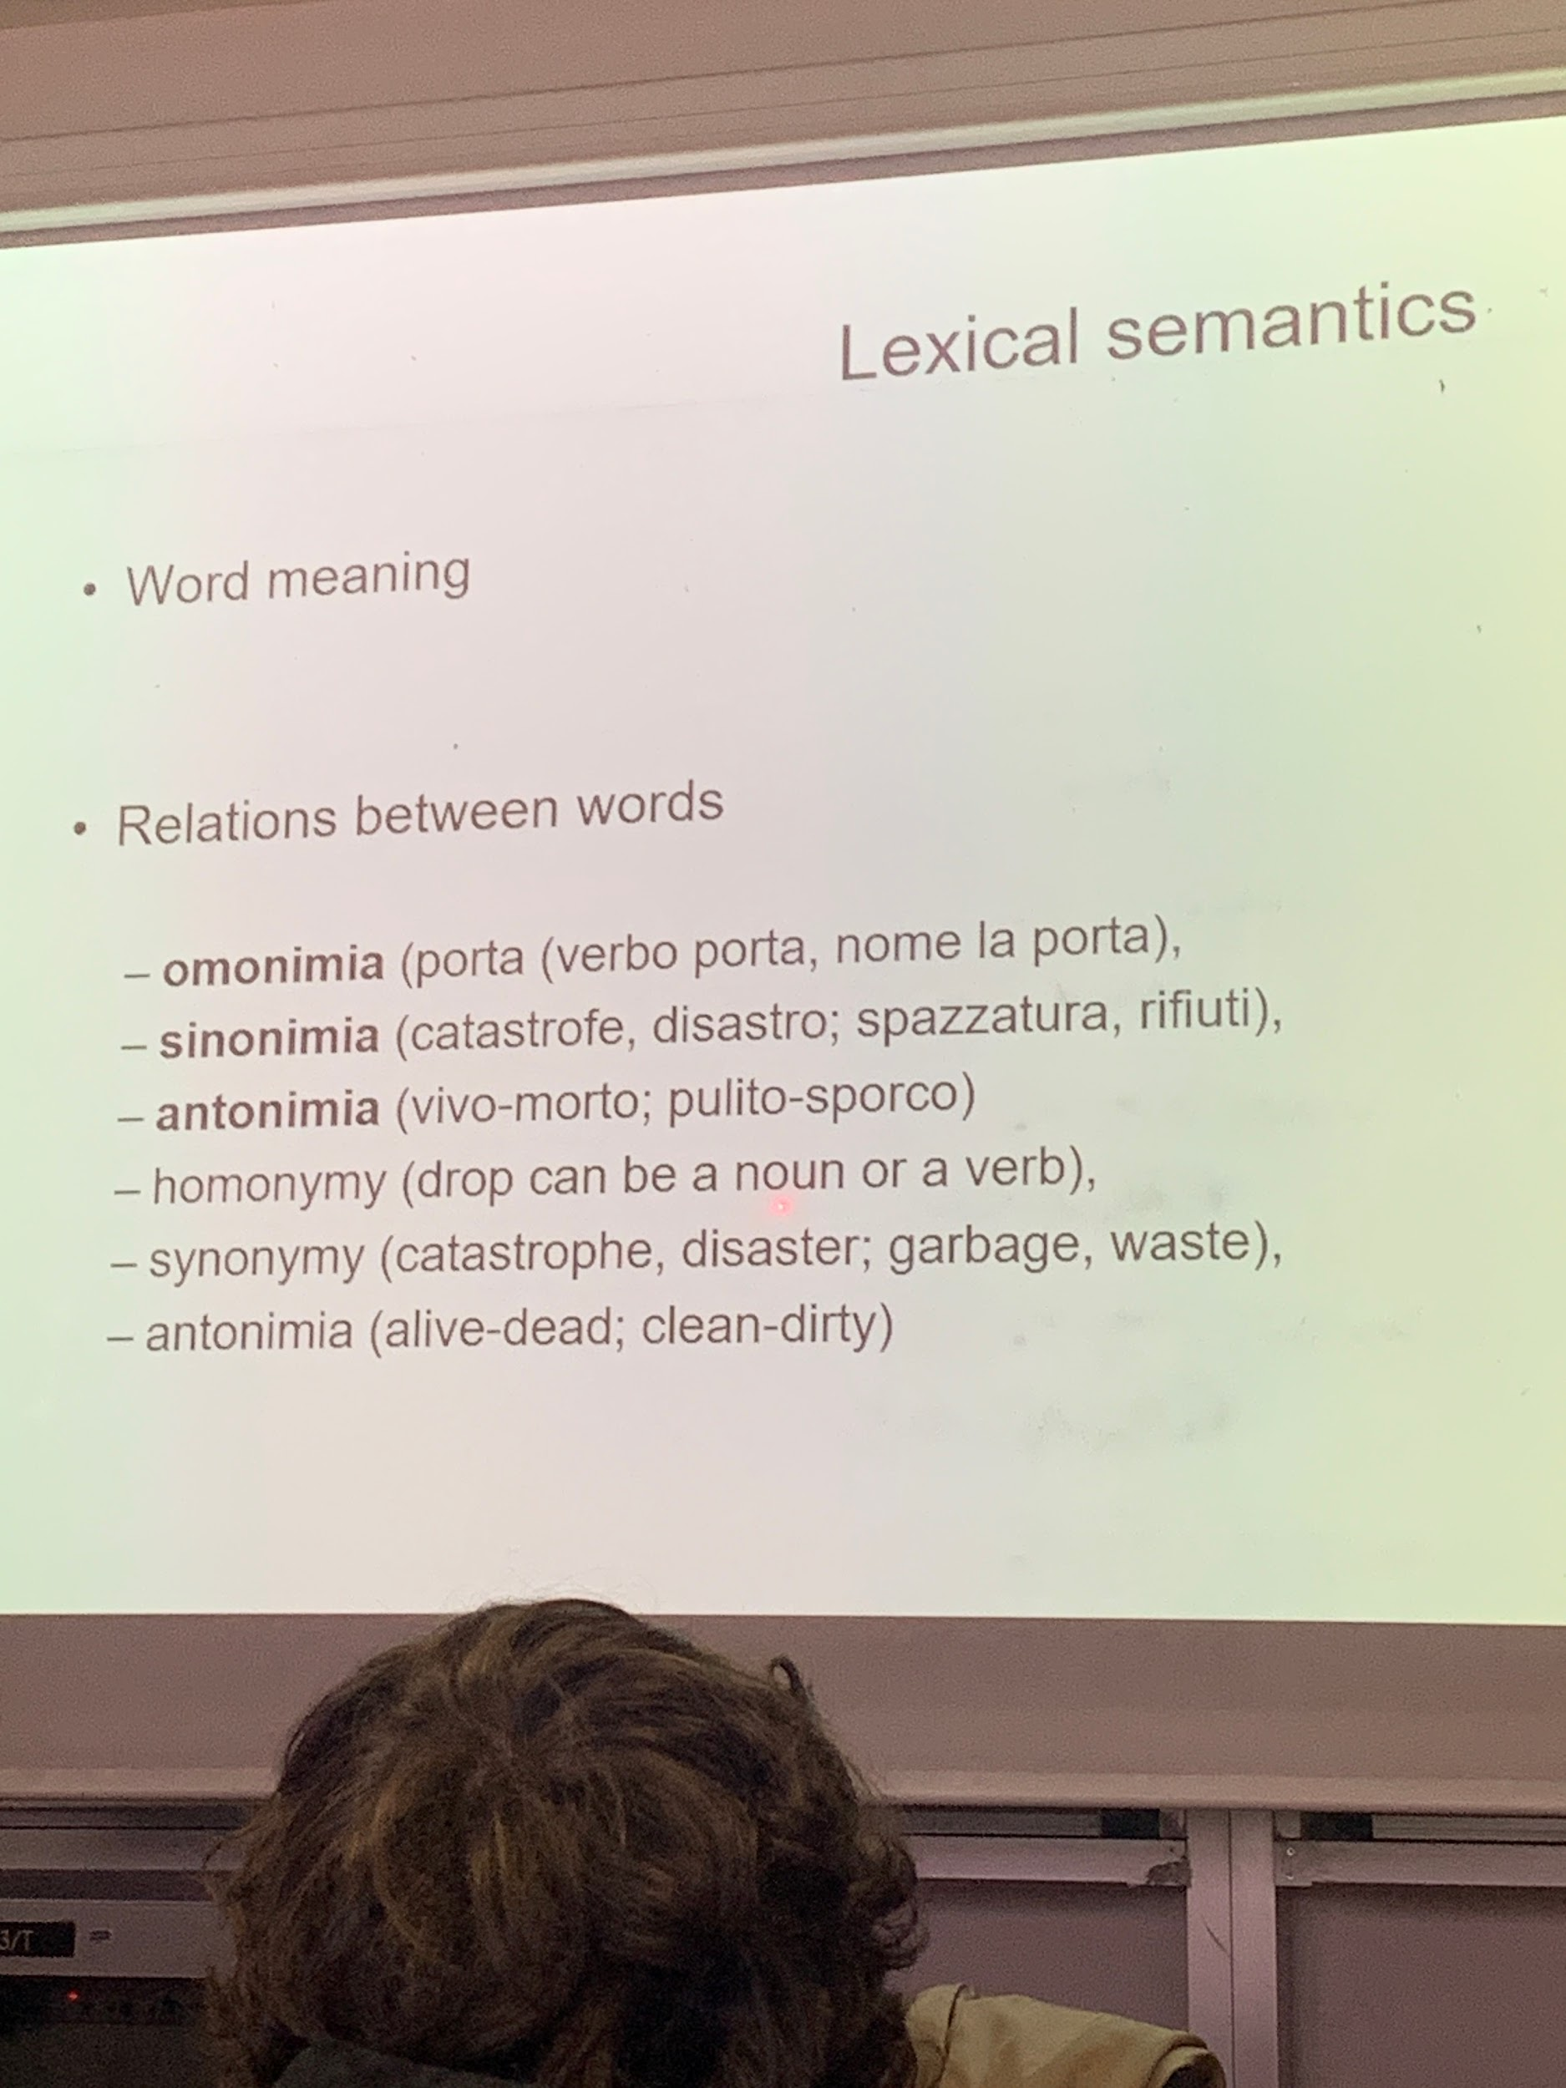

omonimia: porta (carry or door), different meaning, something that have the same sound but different meaning
synonymy: catastrophe, disaster. gargage, waste
antonimia: alive-dead, clean-dirty. If something is alive is not dead, if something is dead is not alive

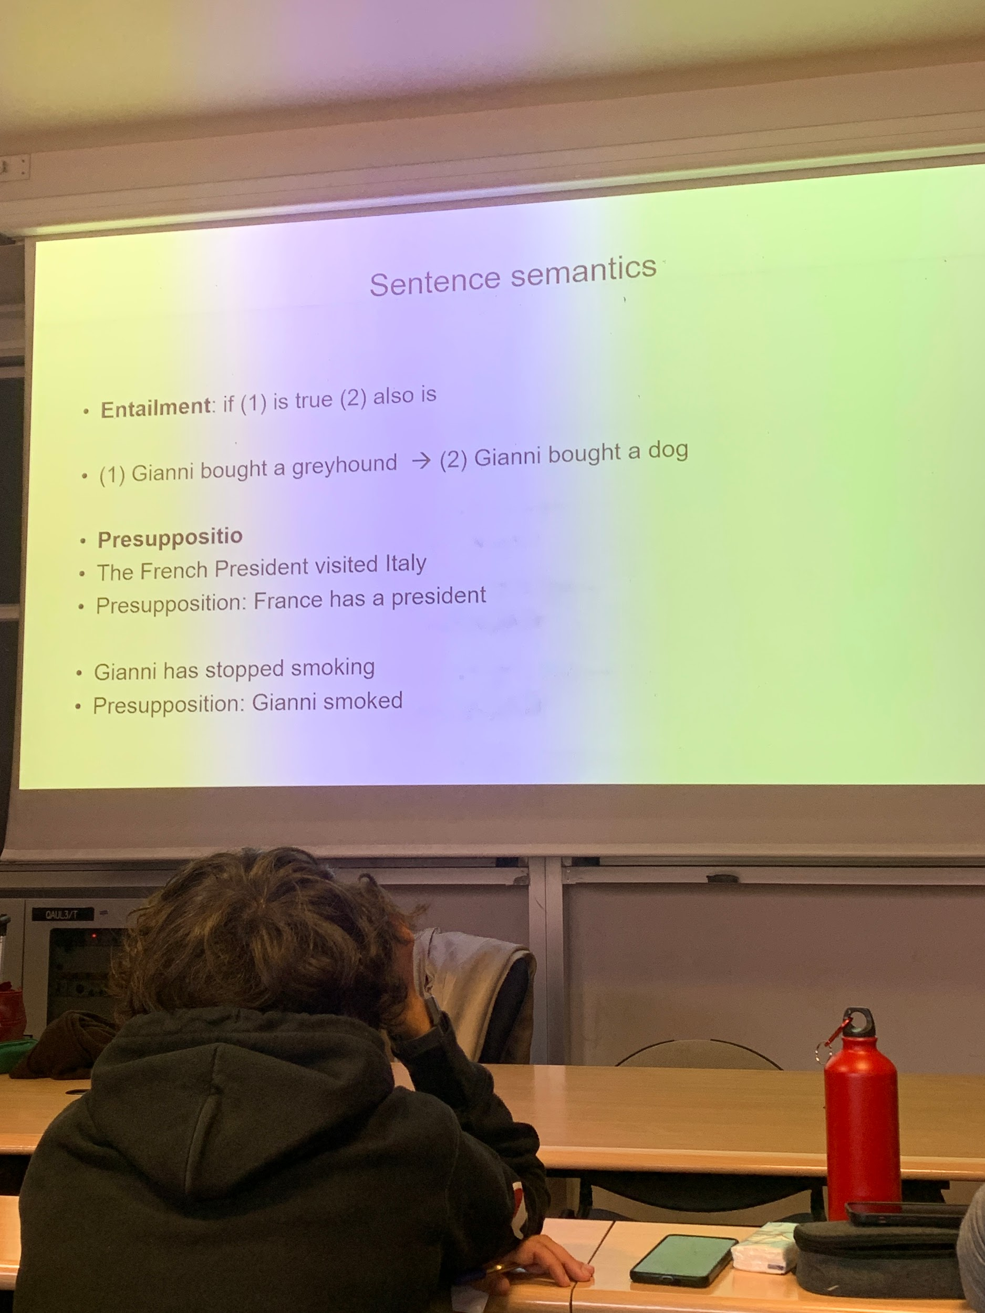
greyhound iìis a type of dog, if 1 is true also 2 is true. entailment.

presupposition

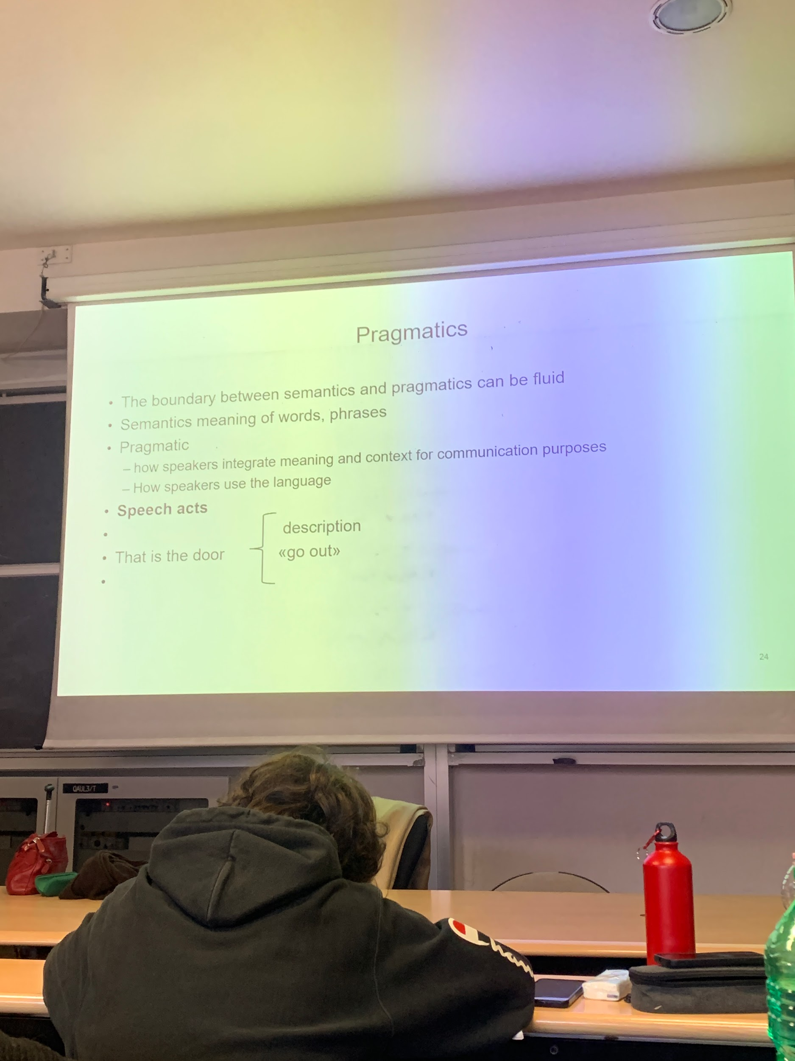
semantics care meaning of words:
pragmatic: how speakers use the language.

that is the door can be use in context to convey different meaning depending on the intonation or the situation. If someone is coming from abroad I can say that this is the door, but if I am very angry and I see this is the door I mean you to go out.

Depending on the context can have different meaning: this is pragmatic context where the sentence is used.

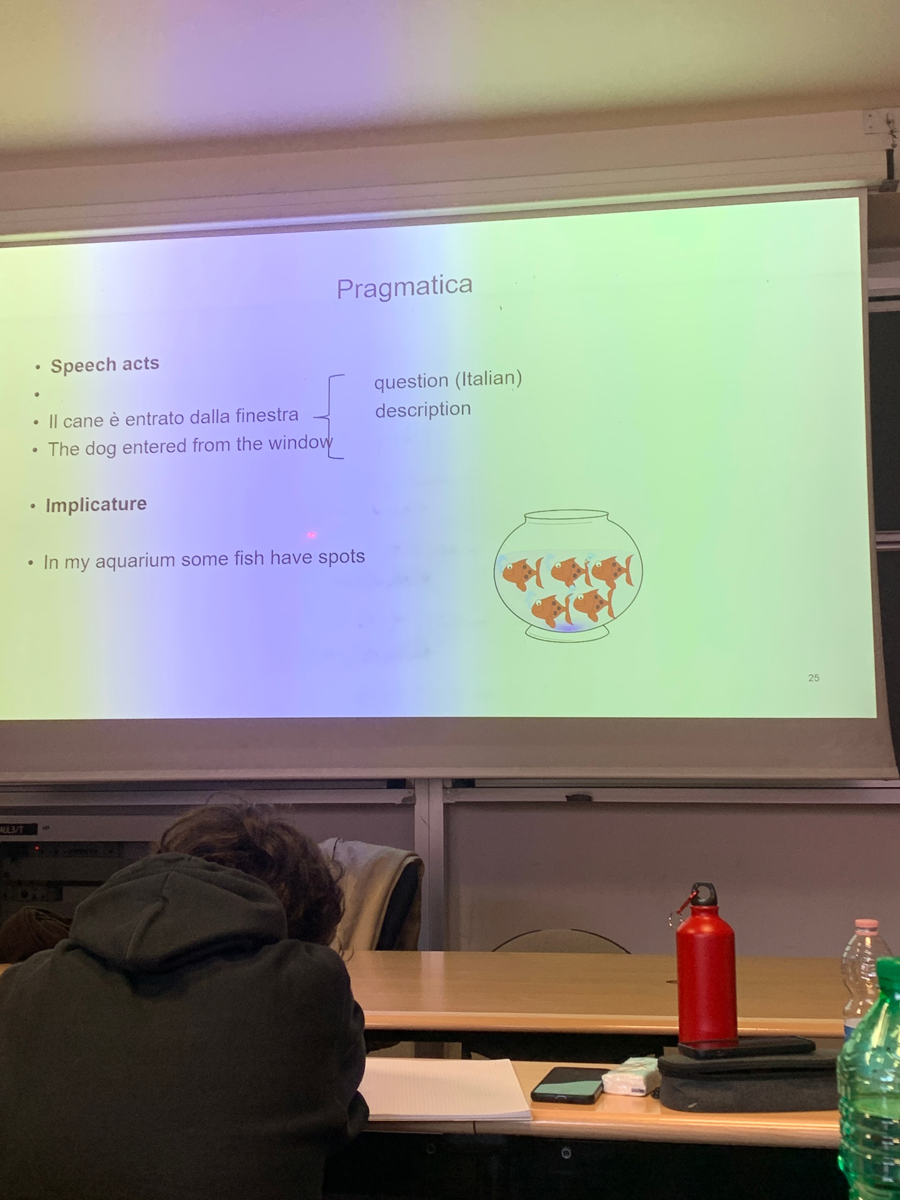
speech act: ordering, promising. I have to have different intonation

implicature: is true, but can say that all fish have spots

----

there are different domains in linguistic, we know what words referet to

tolen, tokenize

Morphology and Morpohsnyicatax

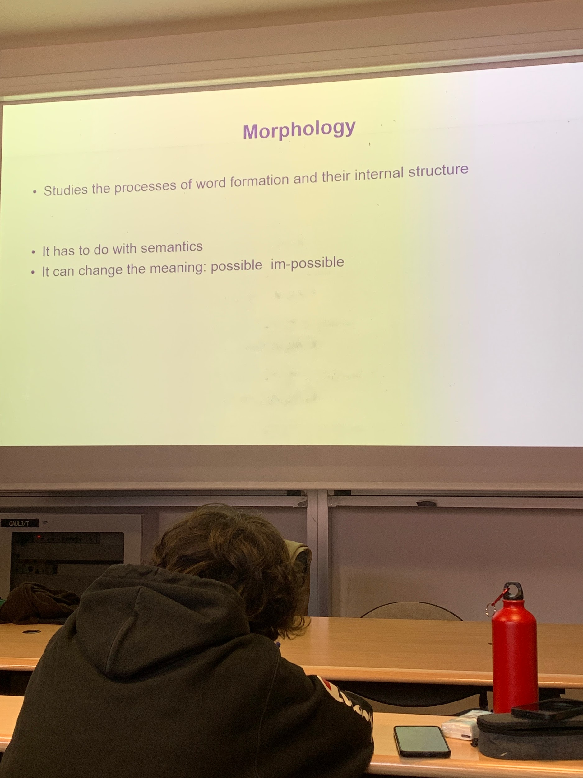

possible: if you add im- it becomes impossible is still an adjective with opposite meaning

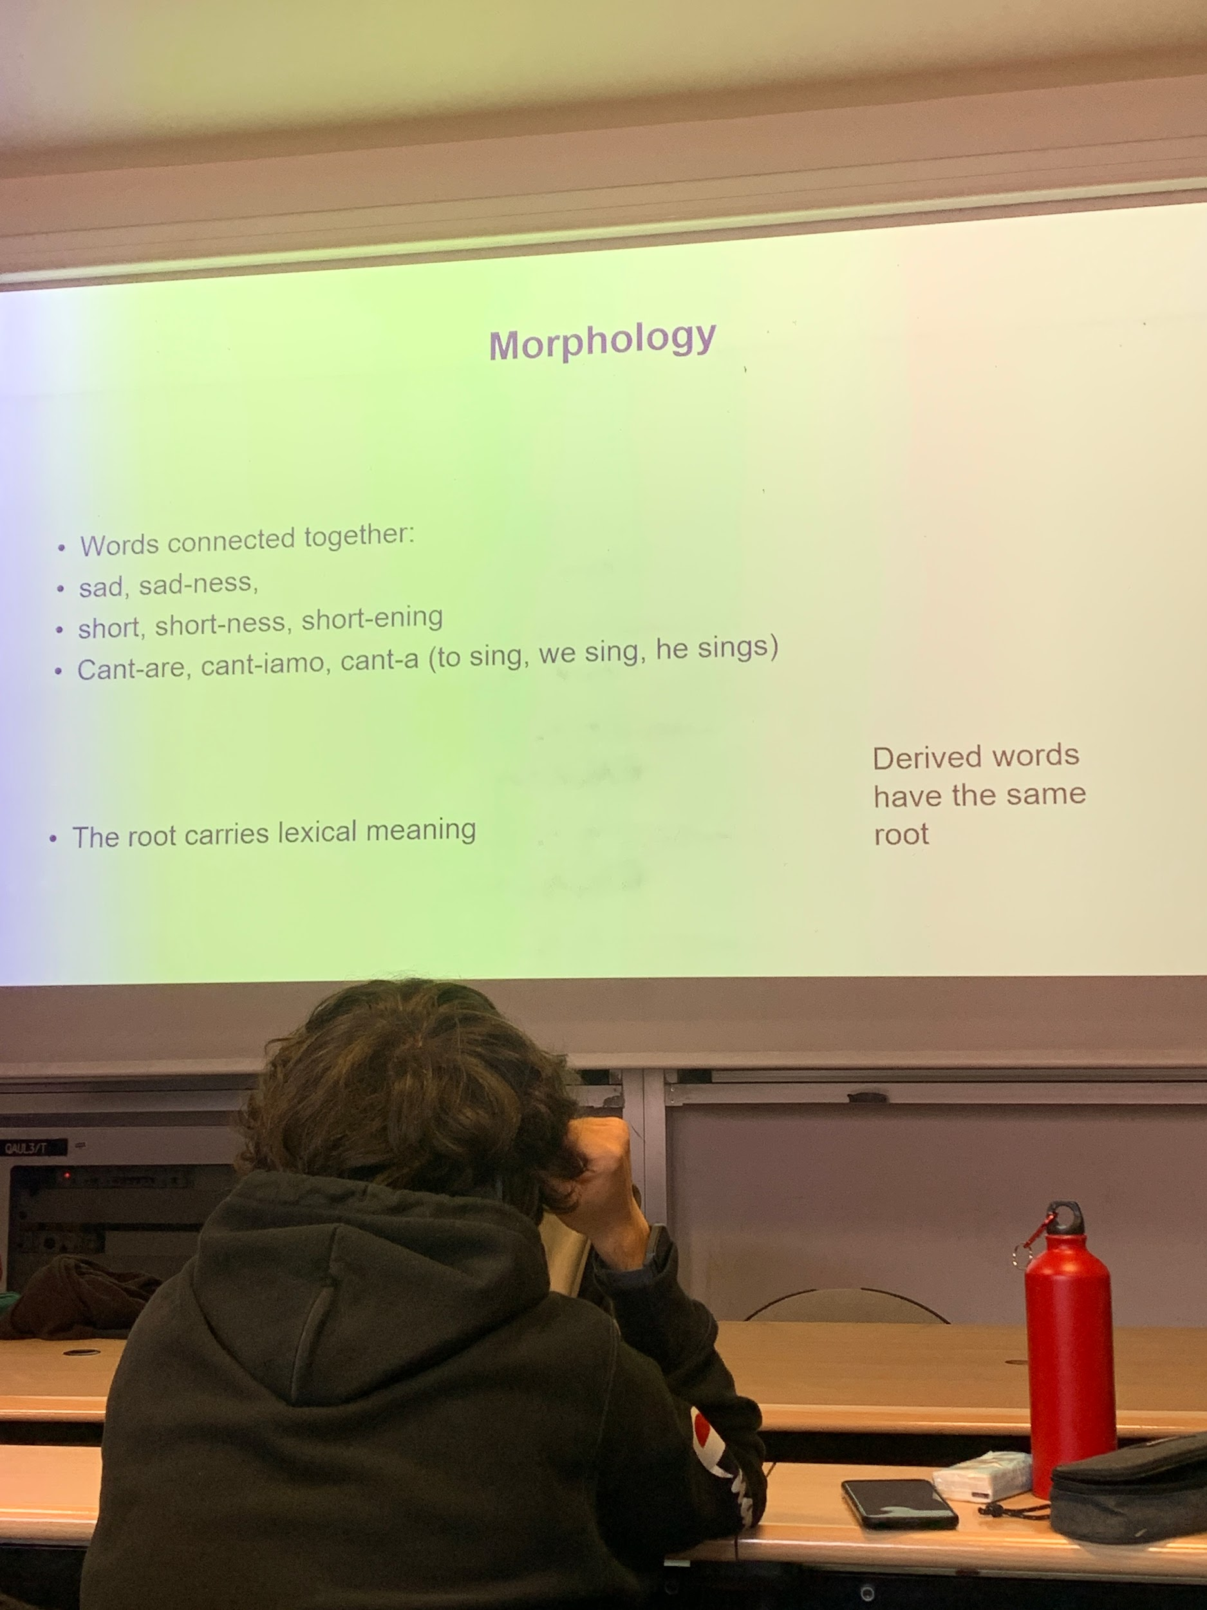
verb cantare: is infinite, we can have cantiamo or canta

there are different processes.

cant is the rooth, it carries lexical meaning. rooth is not a word (cant is not a word by itself). In english instead it is.

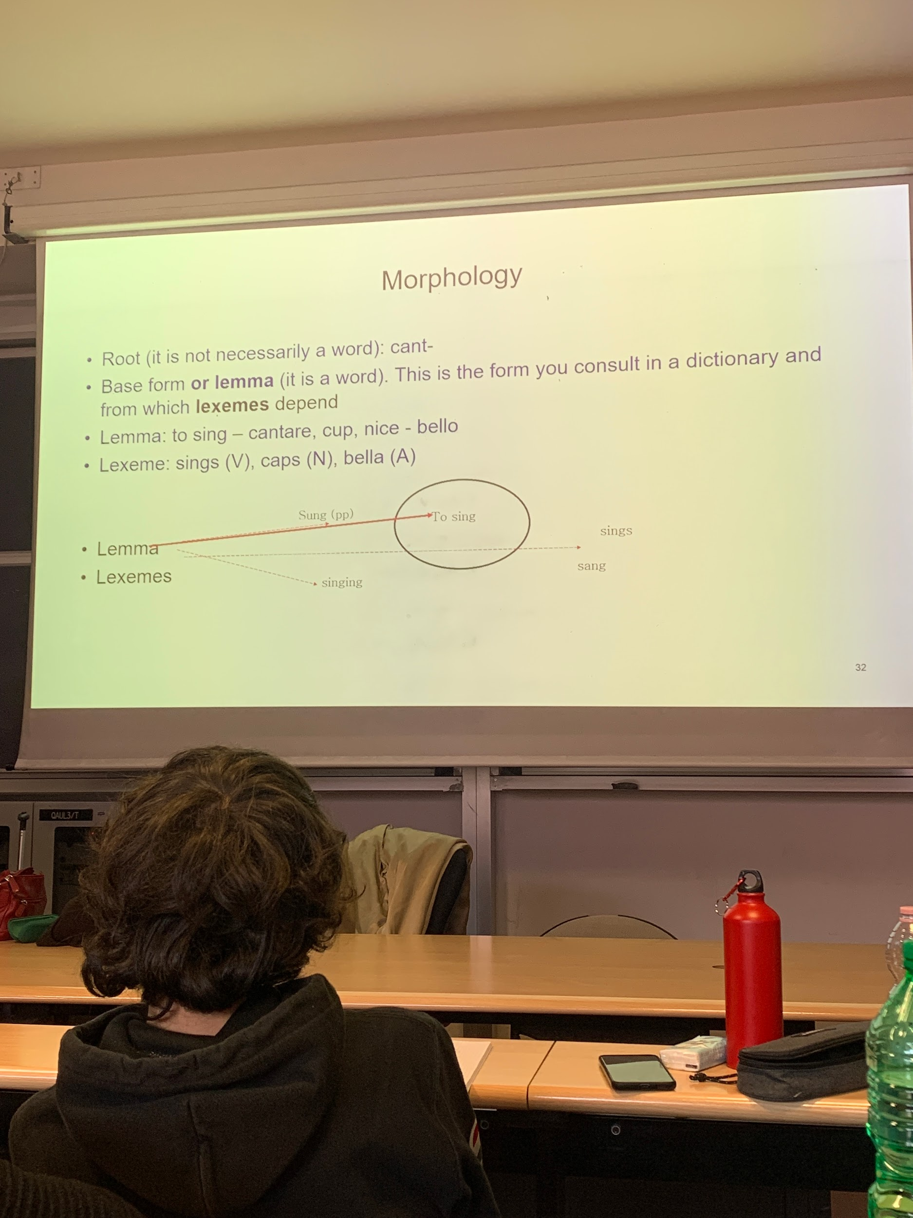

rood depends on the language, in italian is generally not a word, in english yes

if you want to know the meaning of sings. you search in the dictionary sing.

lemma: the base form which is a word (to sing)
lexemes: different morphological formation of the word (sining, sang, sings, sung)

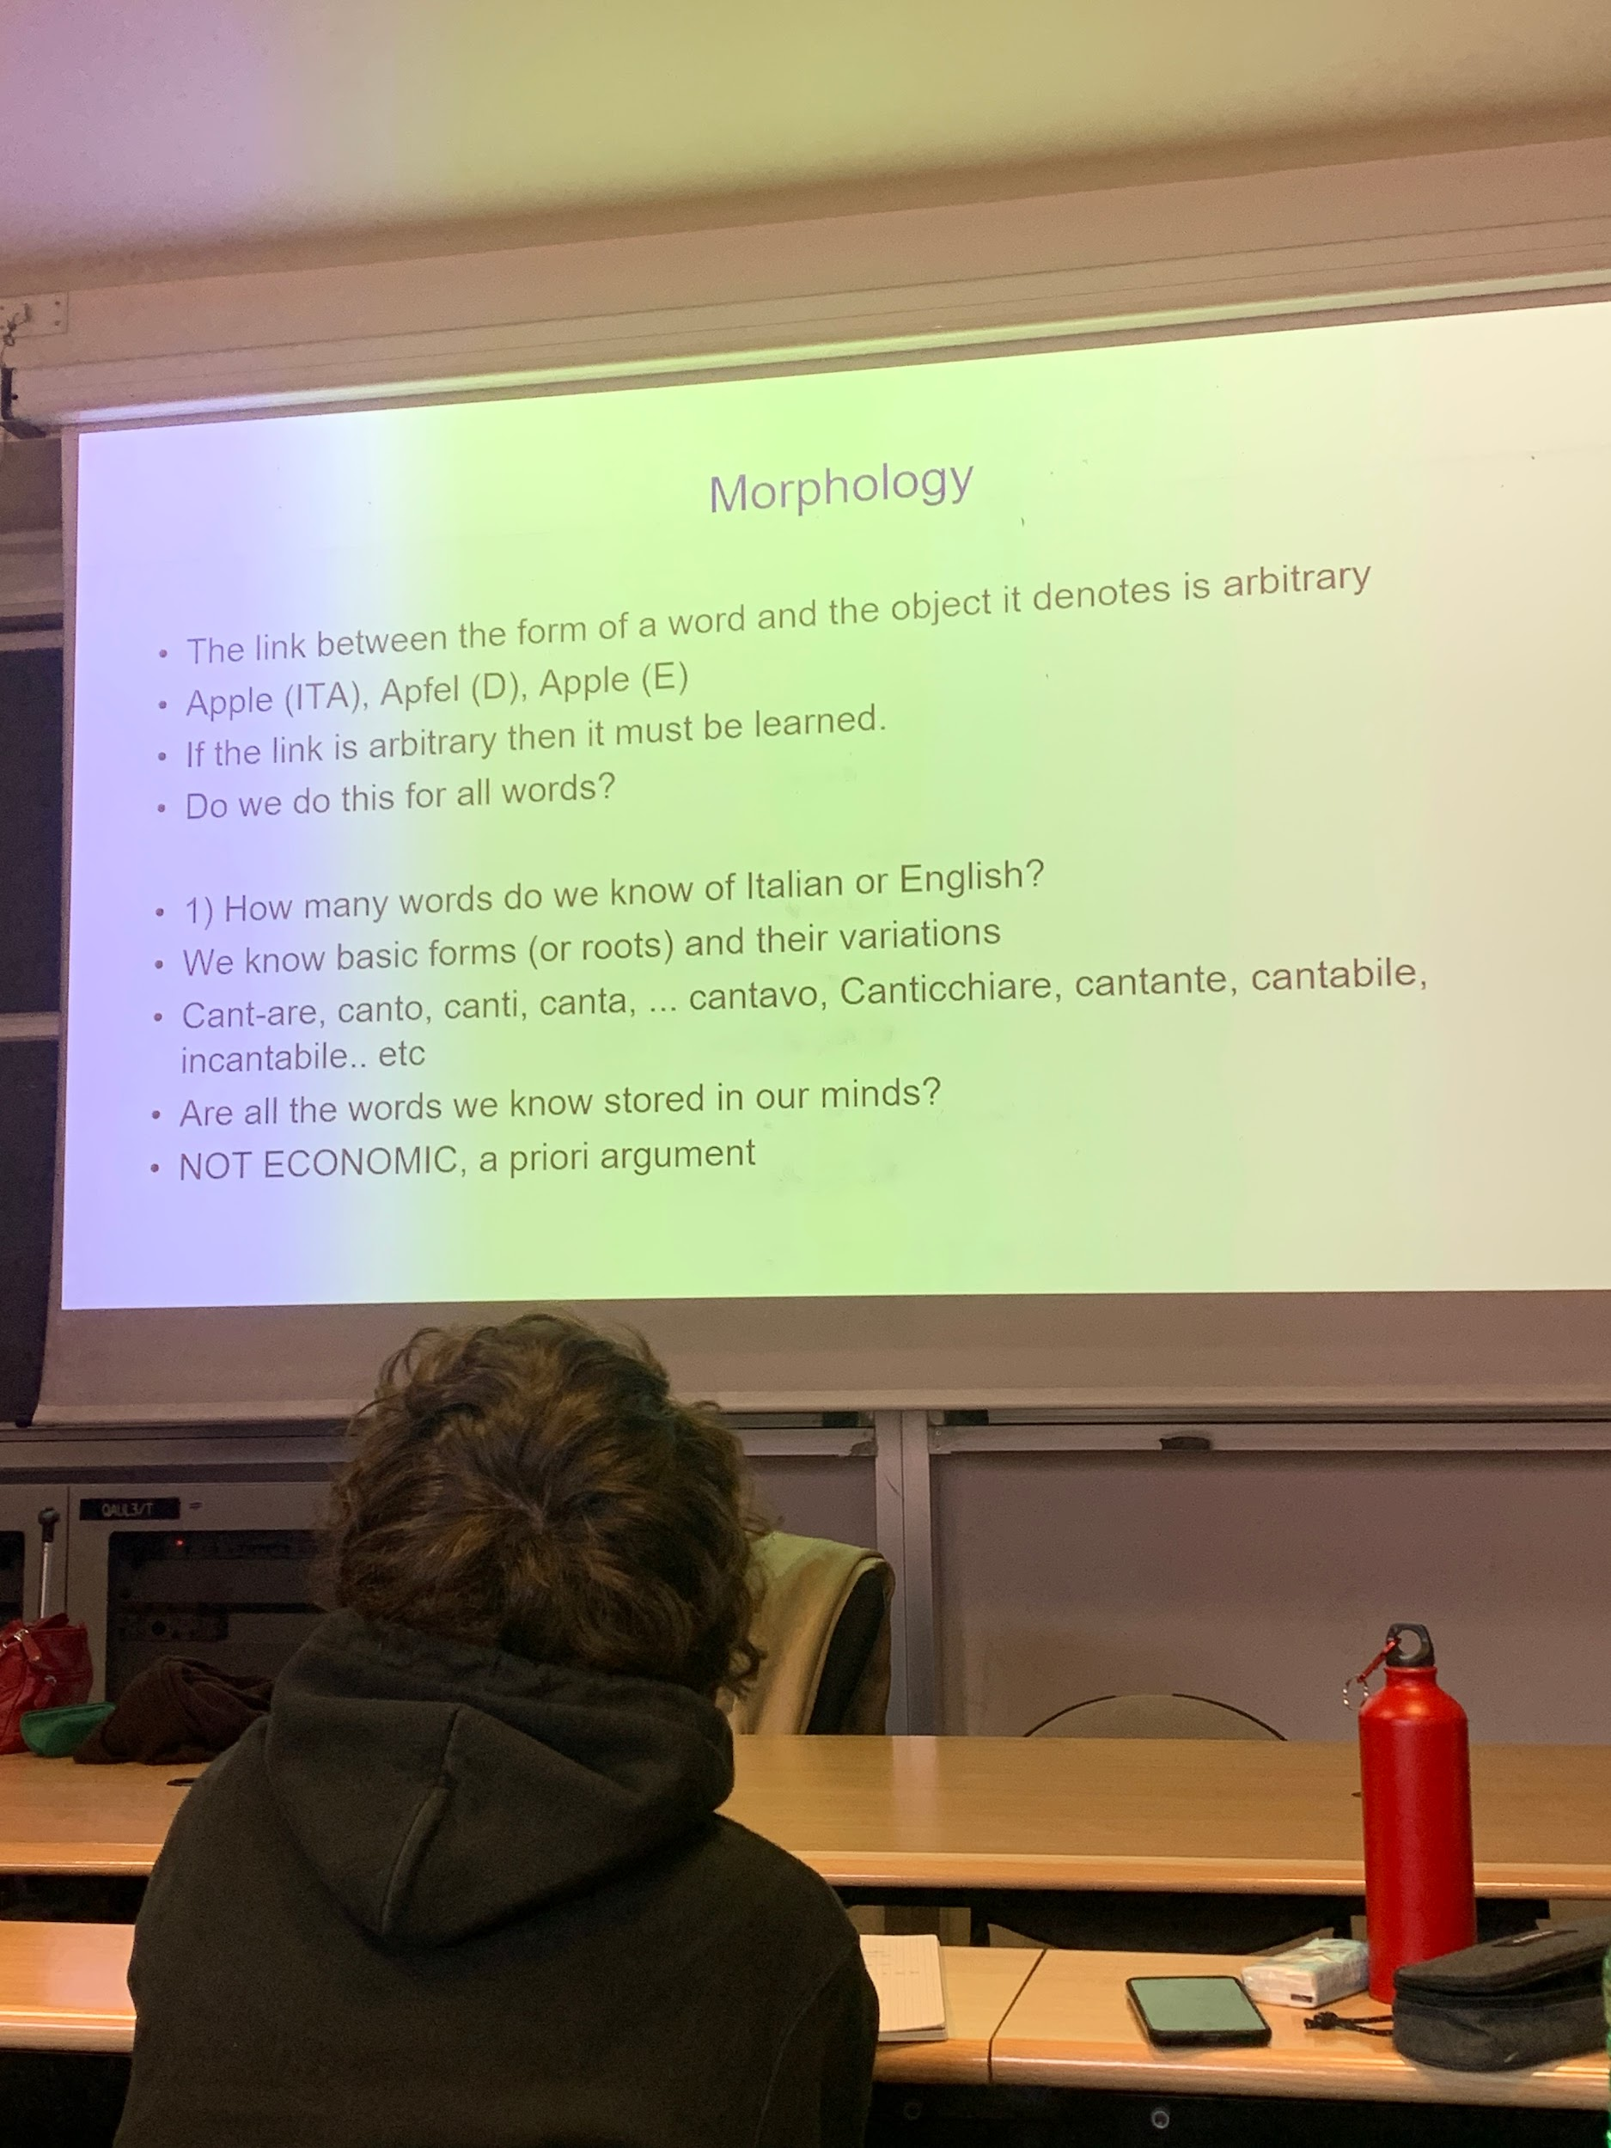
if the link is haribitrary between the form and what is stays for does not meaning I have to learn all the possible forms of a word.

is not economic to do so.

are all the words we know stored in our minds? is not economic

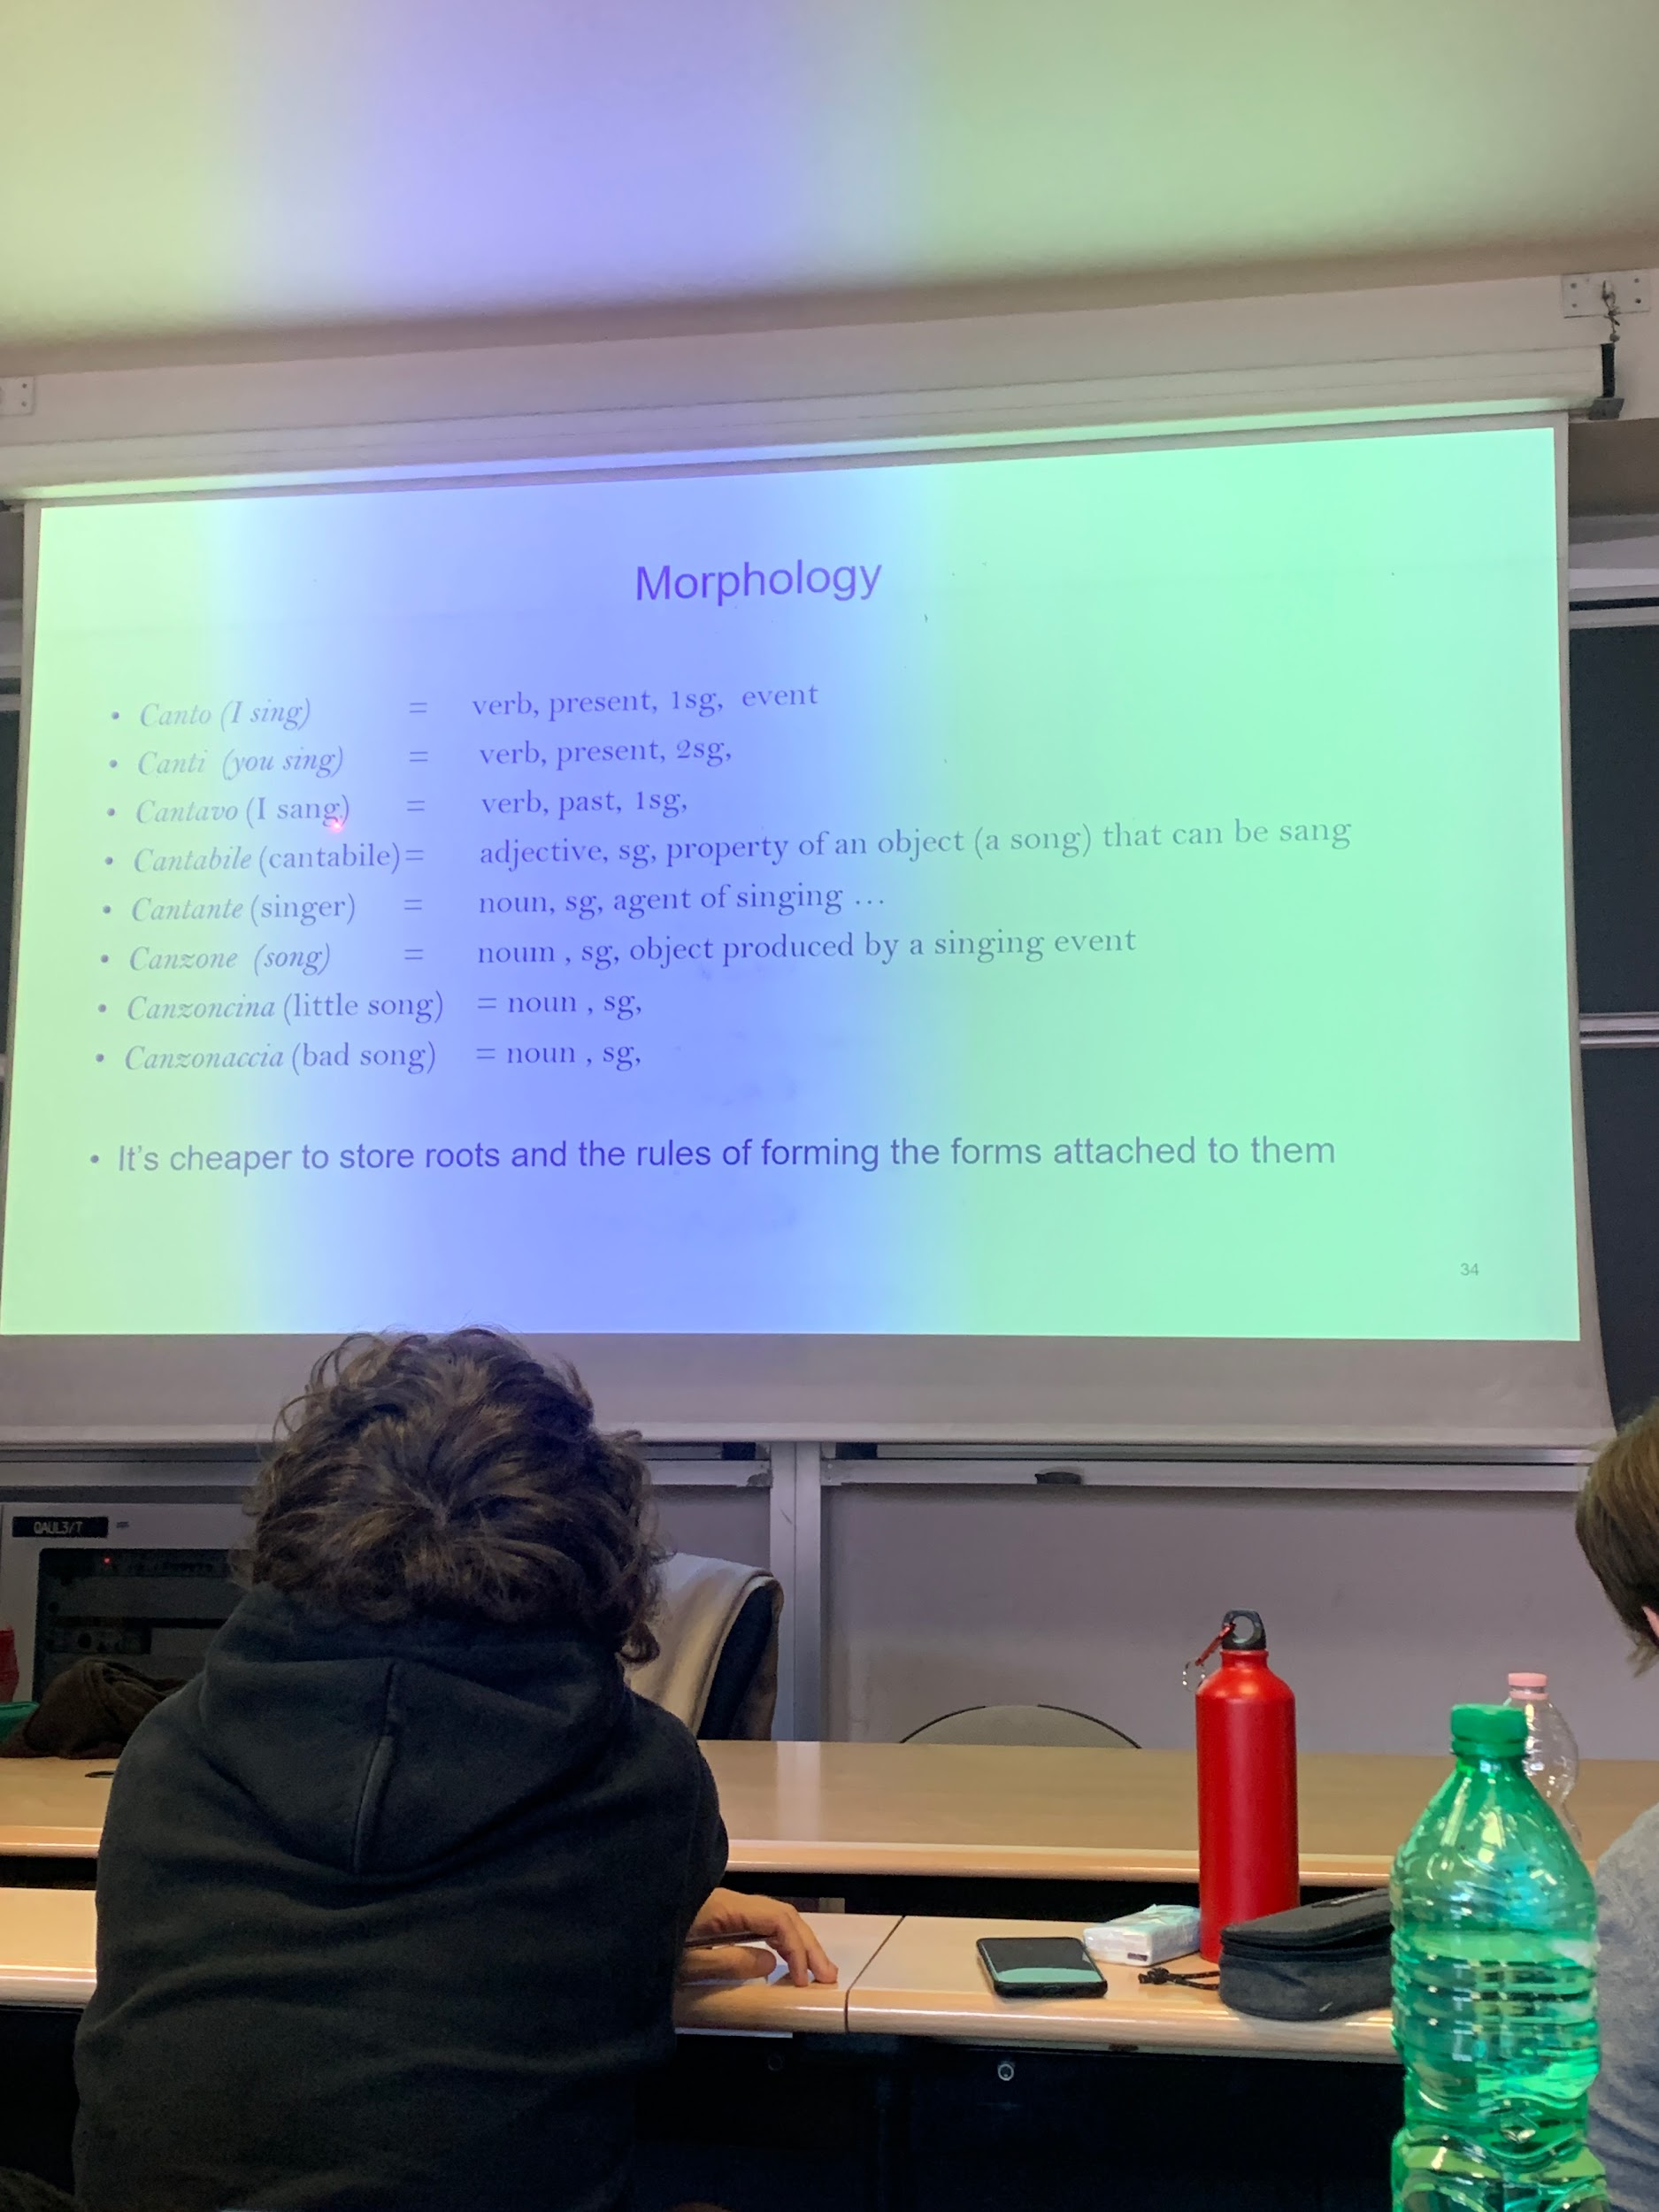

there are commonalities, easier to store roots (aka lemma) or the basic form and the rules of forming the forms and attached to them

don’t have to memoriez all the paradigm or all the variations of the nouns but I have to know the rules and once I know the rules I apply them

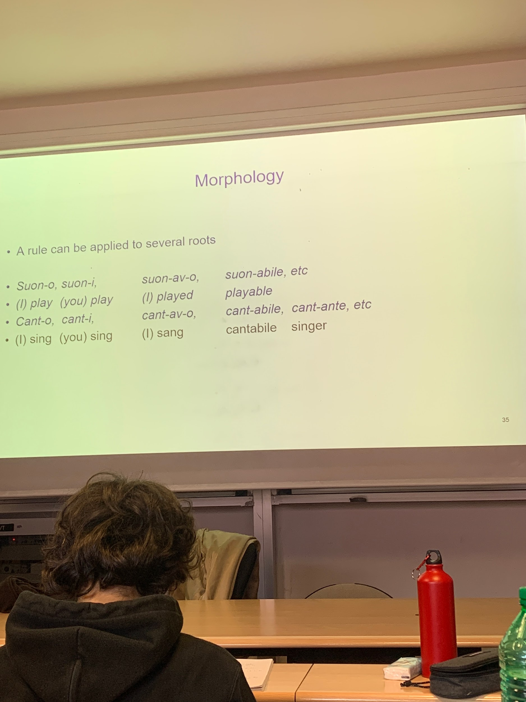

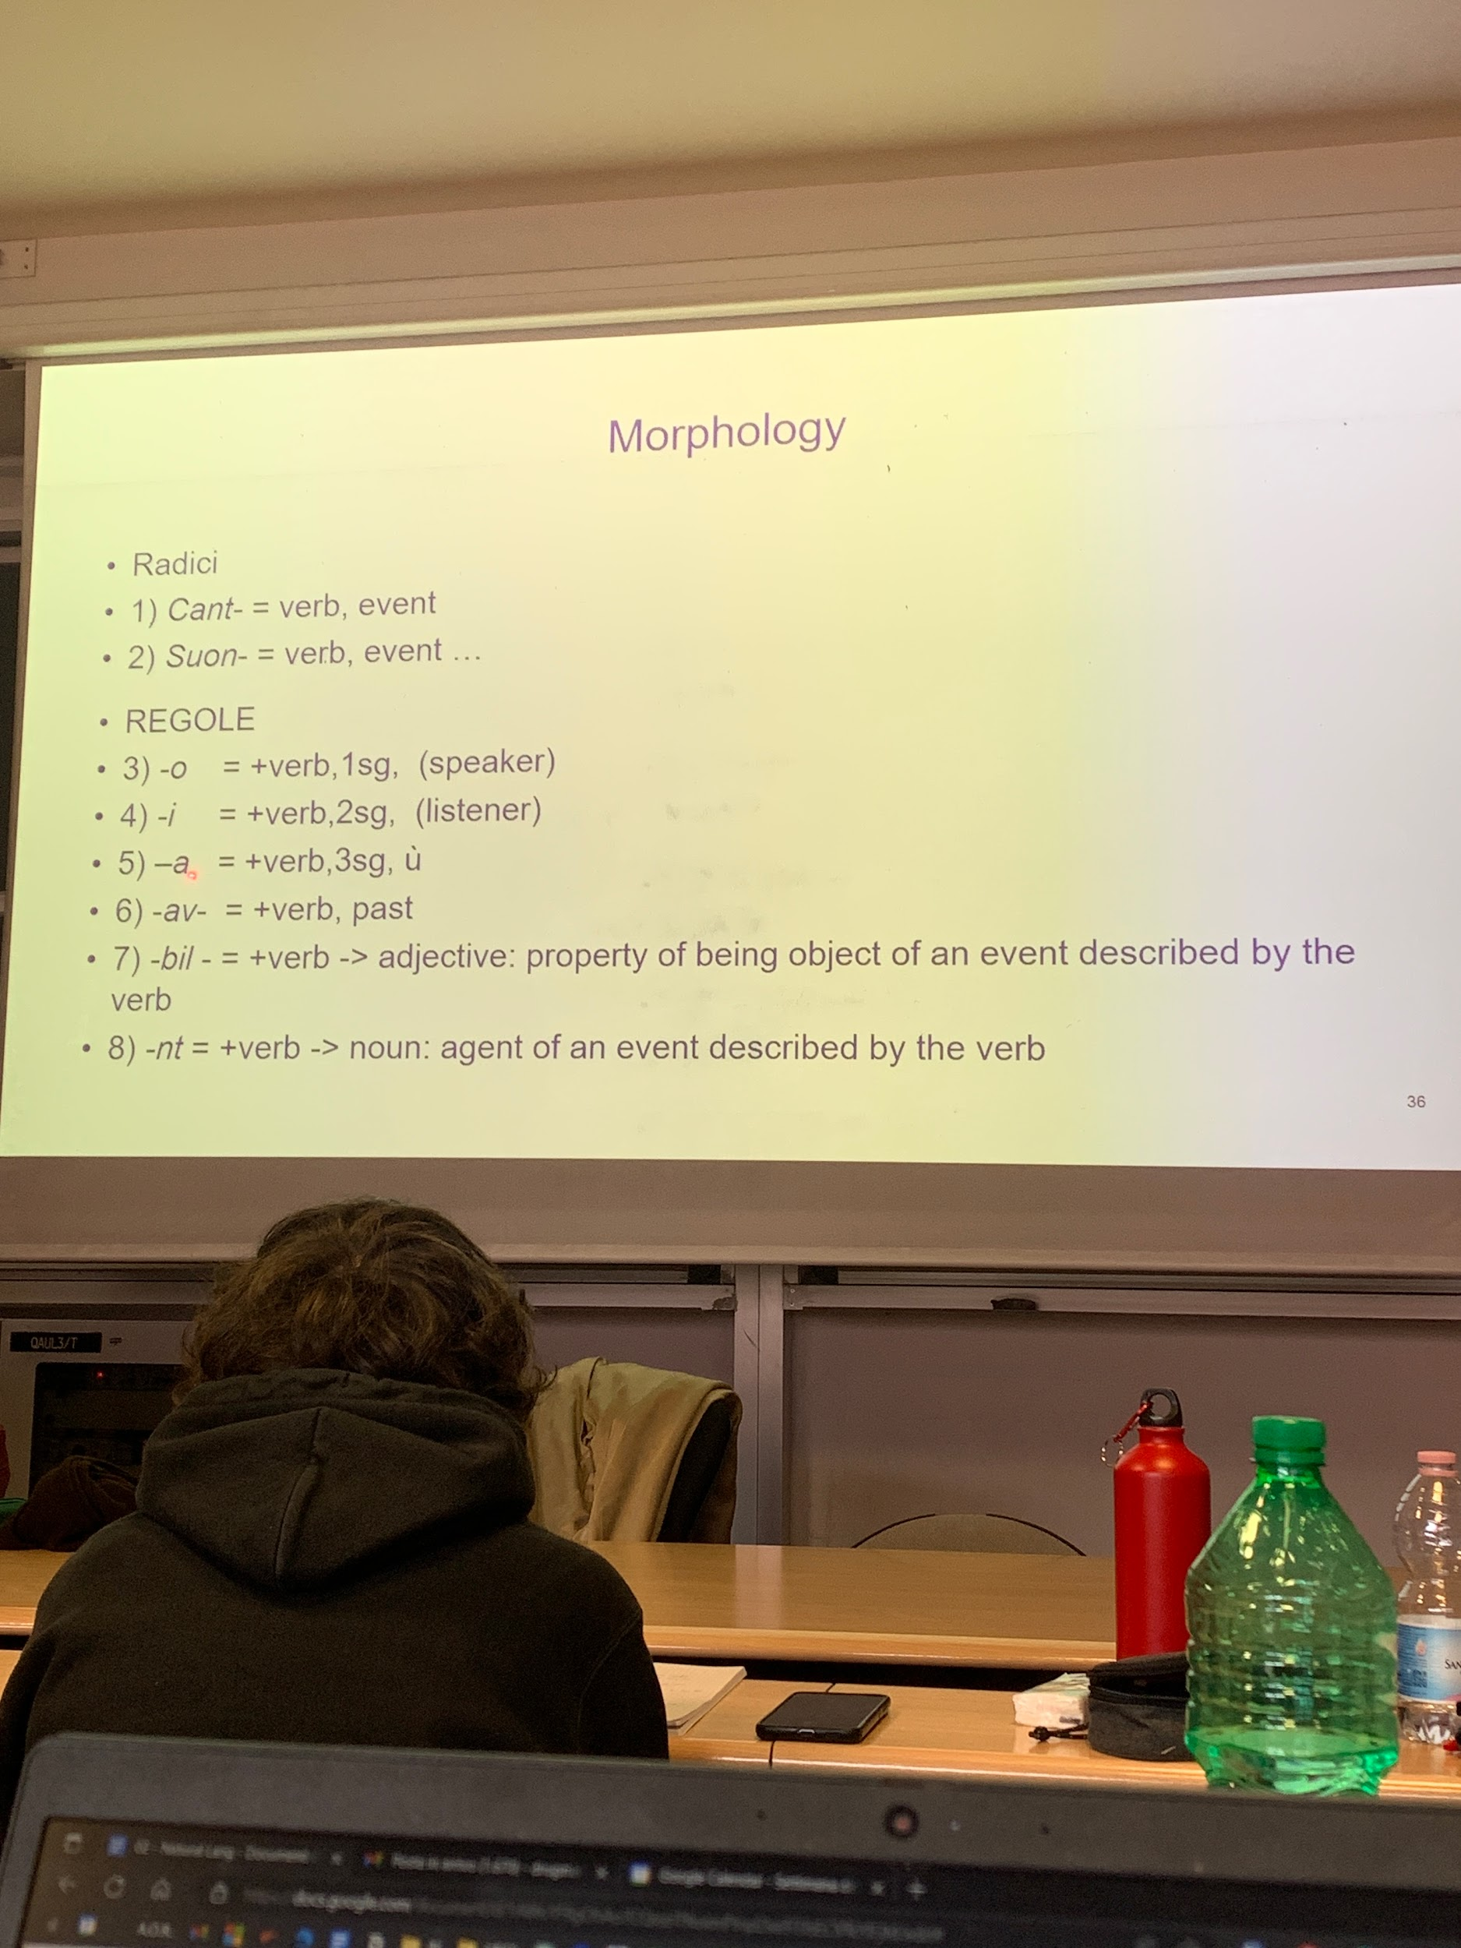

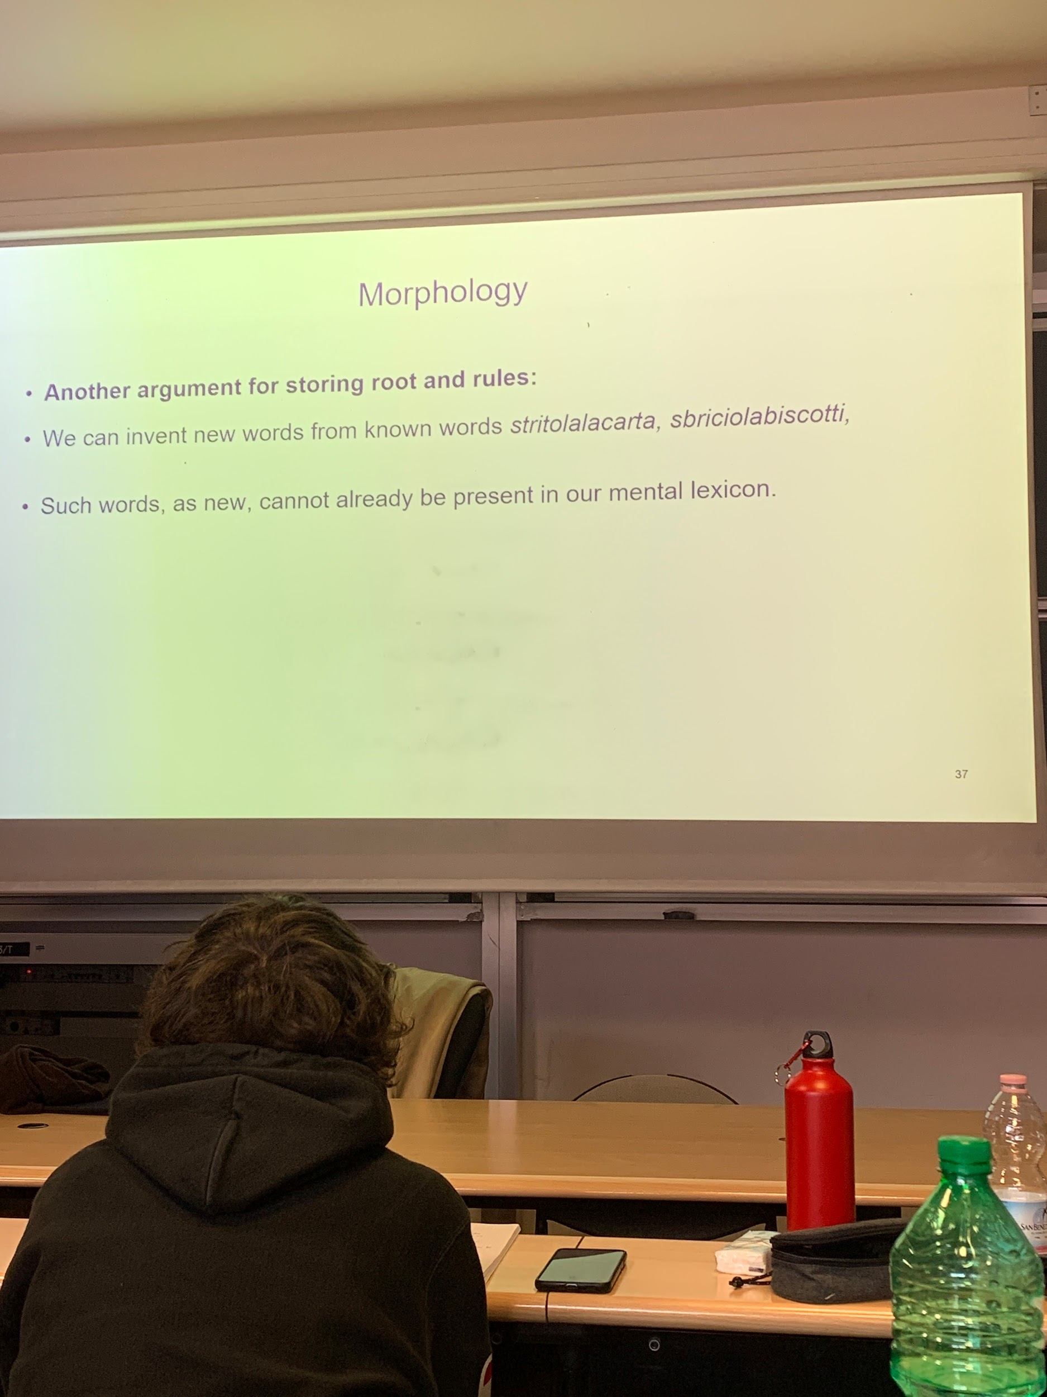
you can invent new words if you know the rules
sbriciolabiscotti

we know the mechanism to form complex words starting from simple words, even from words that do not exists but are permissible

-aio: person who sell the object denoted by the noun it modifies (libr-o ⟹ libr-aio)
mat-o: invented word ⟹ mataio is the sell of mato (invented word)

- er/-or person who does the action referred to by the verb
bak-e ⟹ baker
direct ⟹ director
produc-e ⟹ producer
dollit-e ⟹ dolliter (inveted word)

this suggest that in our mental lexicon we have memorized roots and rules to generate others associated with them

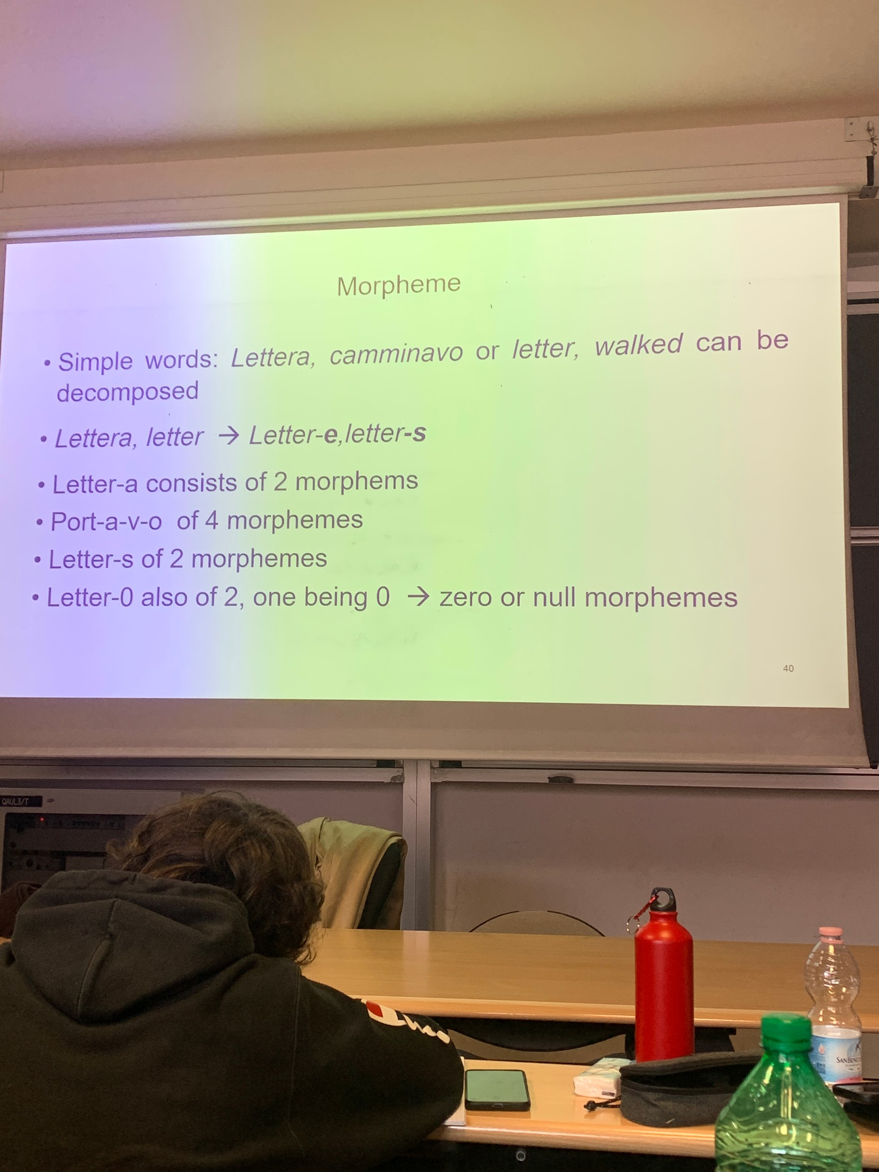
morpheme: the word can be decomposed

letter-a consists of 2 morphems

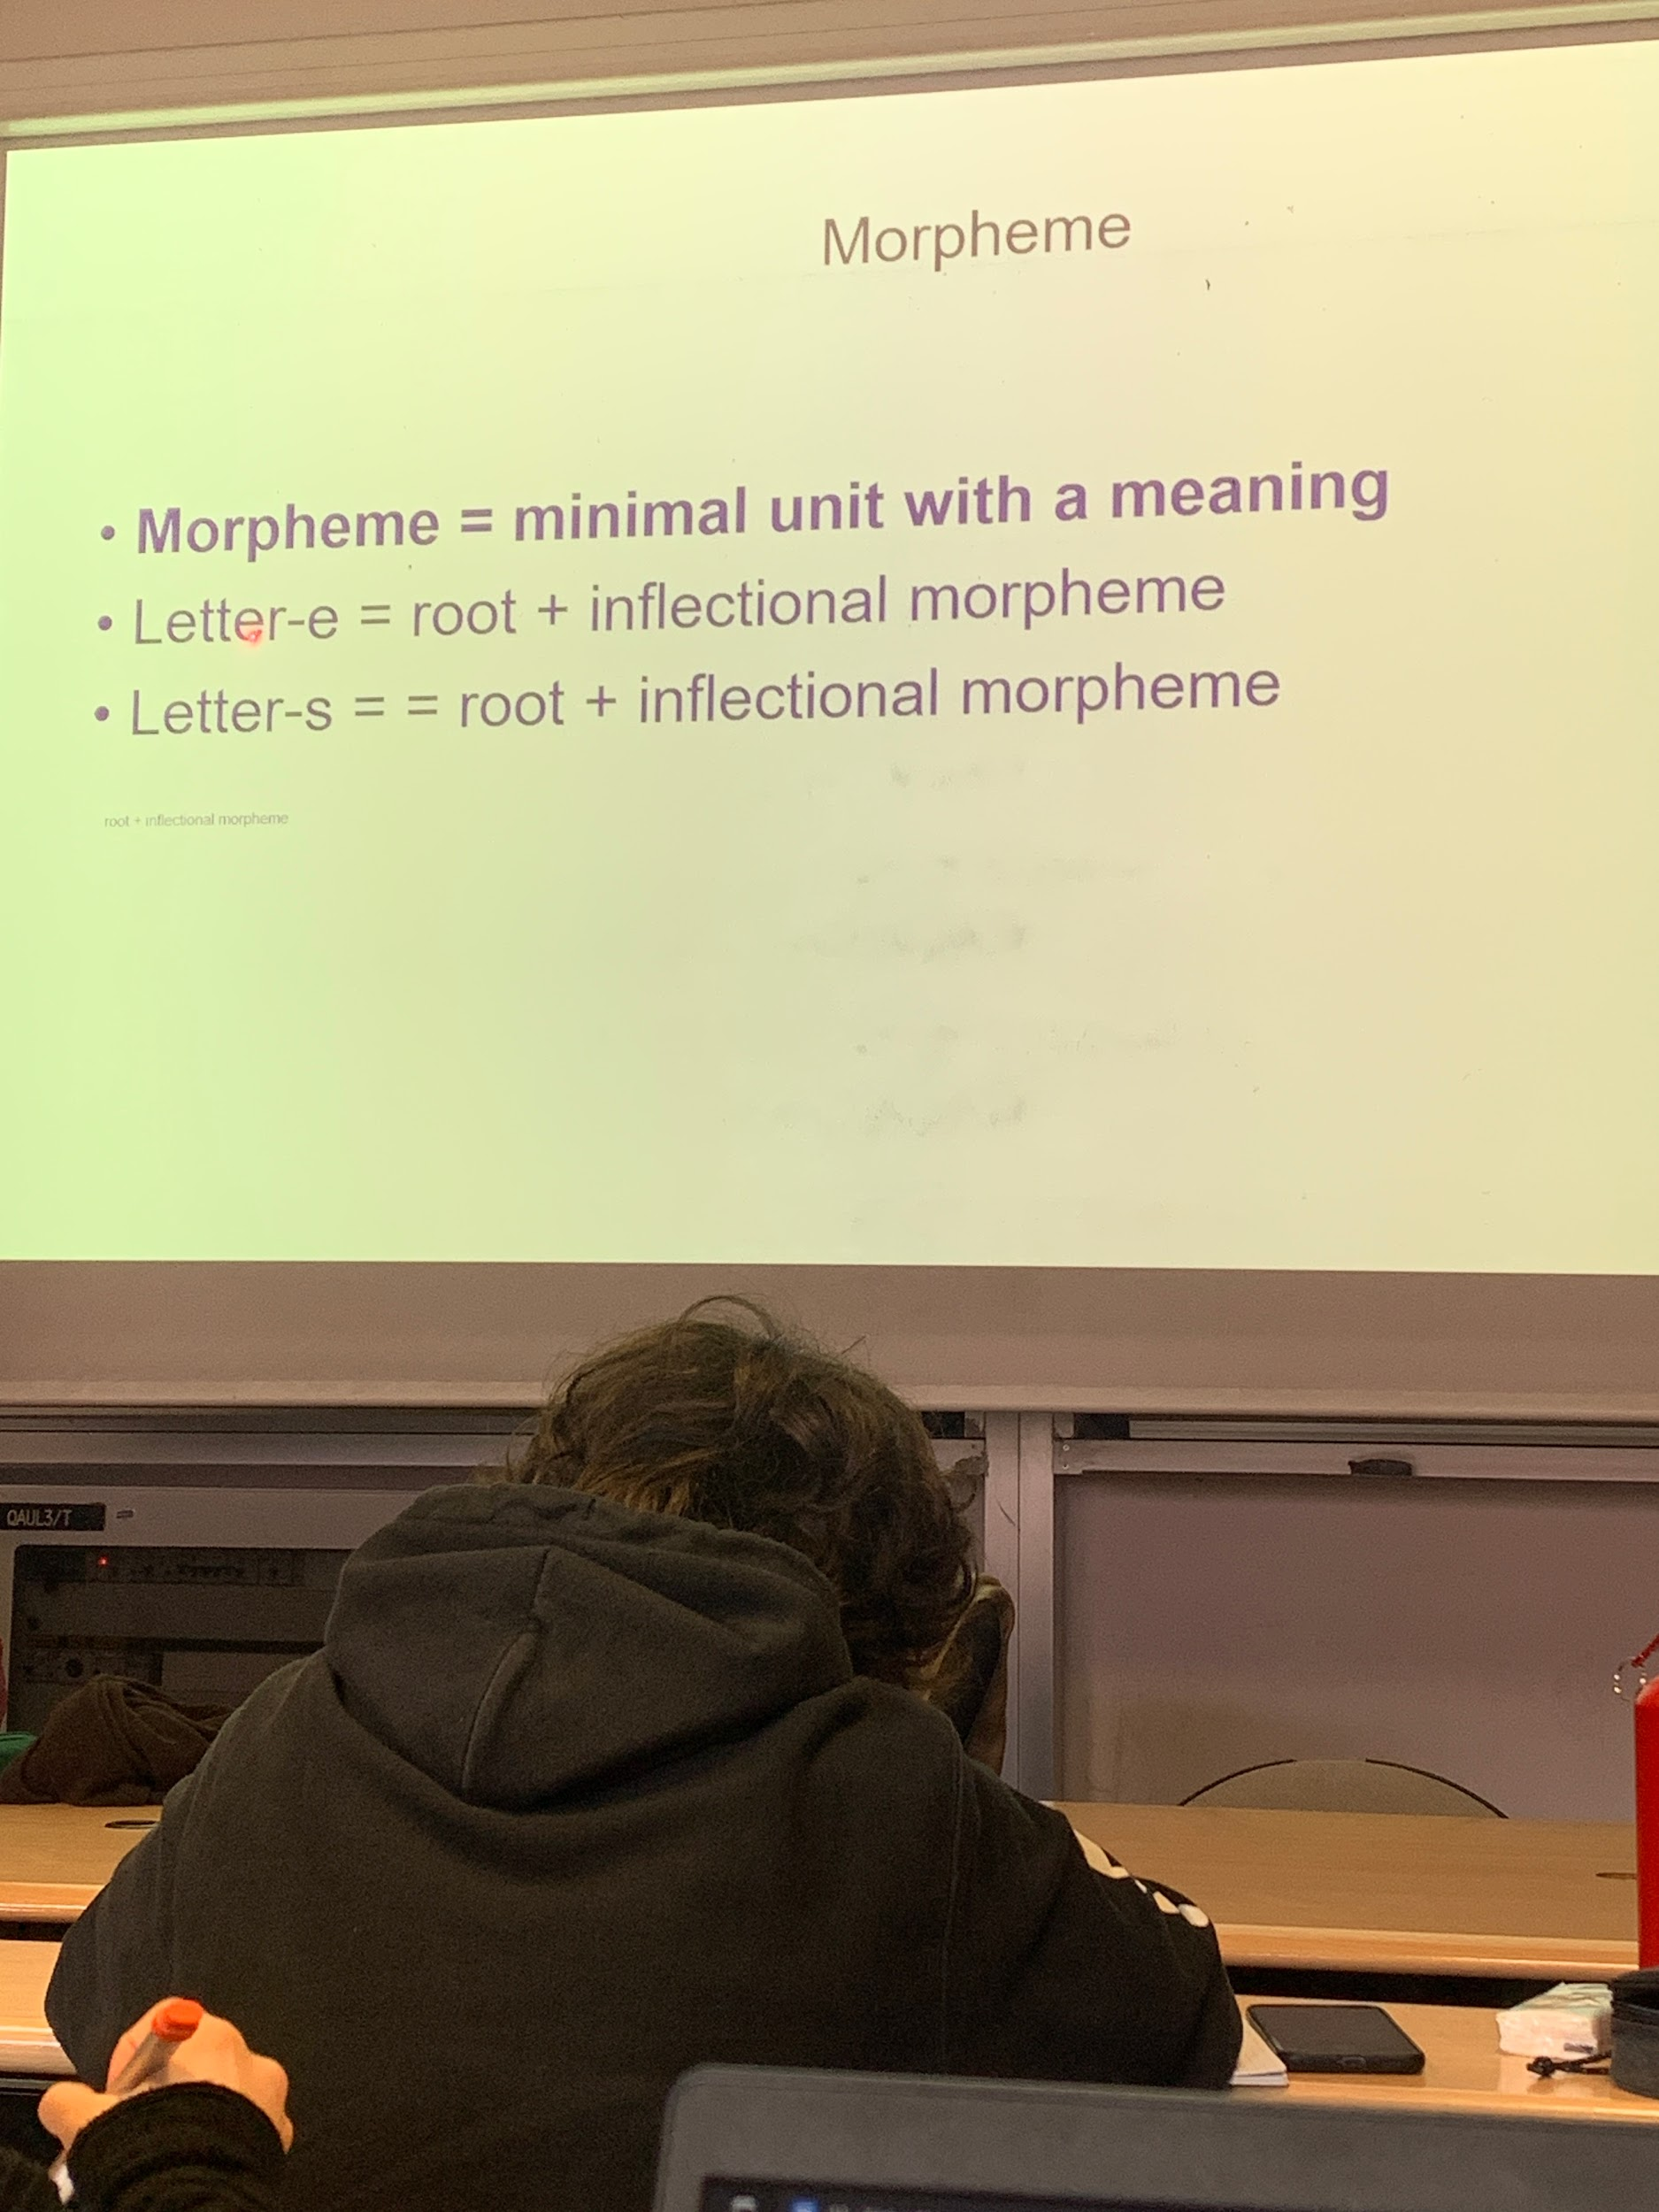
plural: add an information, is a plurality of letter.
letter-s s contribute to the meaning of the word.

root + inflectional morpheme

right now makes no sense, later might have. we always invent new words

